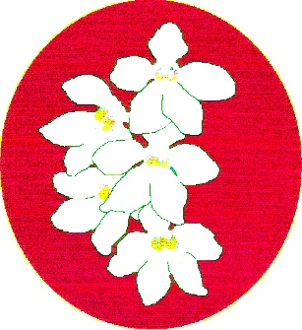
BATEMANS BAY ORCHID AND FOLIAGE SOCIETY INC.
PO Box 3334 Batehaven
NSW 2536
Newsletter – May 2018
President: Ron Boyd 44721934
Vice President: Leanda O’Connor 44725961
Secretary: Margaret Turner 0409442704
Treasurer: Anne-Marie Collins 0427885186
Committee: Rose Boyd, Paula Brown, Min Purtell, Jim Purtell, Ken Covington, Judee Hunt.
Web page: www.batemansbayofs.weebly.com
Email: bbayofs@gmail.com
Facebook page: http://www.facebook.com/bbofs/

Presidents Report
Welcome all members to our May Monday 7th club meeting.
At our May meeting will be having our bi-annual auction, please bring any items you may think others would like to buy, Orchids, books, preserves, etc.
Thanks to Peter Vanest who gave an interesting talk on how he grows his Pleiones at the April meeting. Check them at the next show where Peter presents them so beautifully. Peter stated he hoped to have plenty of them in flower for sale, such a lovely miniature orchid.
Our bus trip to St Ives Friday 17 August 2018 is up and running. Please get in early and book a seat. Bus timetable and route are attached with St. Ives Show flyer with vendors listed attached as well.
For the newer members who have never been on our bus trips, while sitting a few hours may seem a long time, friendly chatting with other members soon passes the time and we do have a break of about half hour both ways at McDonald’s at South Nowra. The joy of seeing the other clubs’ orchids in display is brilliant and the sales table full of beautiful orchid and perhaps that flask you may have been after. I never miss the chance to have someone else do the driving for me up to the show.
Thanks to all members who bring in flowering orchids each month to place on the display benches. They certainly brighten up the room and show case what our members can grow. Our new members also get a good idea of what can be grown in our wonderful climate.
The committee met on last Monday 16th April and discussed bring back the ‘Lucky Door’ prize in some form. We are looking at starting it again, hopefully at our May meeting if all goes to plan.
It is nearly May and winter is slowly approaching, there is still time this month to finish repotting all your Sarcochilus. I have noticed mine are putting out new root growth since the summer heat has passed. Lots of other orchids that need repotting can be done now while there is still warmth in the air.
Light hearted idea for those who do a lot of potting; personally I would love one, check out
https://www.facebook.com/leo.zwinkels.5/videos/1549169745205967/UzpfSTEwMDAwNjM3NjQ3NjM0MDoxOTcwMTA4MDY5ODc4Mzkw/?id=100006376476340
Sincere thanks to all the members who bring supper along to the monthly meetings, your efforts are very much appreciated. We are grateful of your continued support and assistance.
Karen Ruiz of Mogo Orchids and Fern Nursery are now stockist of all your orchid needs, pots, bark, fertilizer etc., just give Karen a ring on 44742291.
Good growing
Ron

Other items
- May is an uneven month so members with an even membership, it is your turn to provide something for supper. Thanks.
- Growing experience plants for 2018 were given out at the February meeting. If you have not collected one, Ron will have them at the May meeting.
- You will see in the minutes that members discussed running the BBQs intermittently to help with fundraising. If you are willing to help please let Margaret know. I am not going to be the person running/storing the items but am happy to help. We are still looking for a member to take over the running of them on a more regular basis.
- Remember to save the bottom of the 1.25L soft drink bottles for posey making.
- Please note the item in the minutes relating to the reduction of prize monies for the Open Sections in all shows.
- Leanda has also taken on doing the get well cards etc, so please let her know if any member is unwell.

Our Next Meeting
This is one of our auction nights. Any item that you would like to put on the table can be part of this process, NOT just orchids.

Membership renewal
Memberships are now overdue for 2018. These can still be paid at the May meeting or by sending a cheque or money order to the postal address at the top of page one (1). If memberships have not paid by 30th April 2018, you will not receive any further newsletters, nor will you be able to bench at Club nights or shows.

Bus Trip
Members present at the April general meeting agreed to the proposed bus trip. The trip will be on Friday 17th August. Bus pickup times are attached to the end of the newsletter. BBOFS Club Members will pay $15.00; non-BBOFS Club Members will pay $25.00.This is bus trip cost only and does NOT include the admission fee of $4.00 per person. Ron is following up if we can provide a cheque at the gate or if cash is required. We will keep you posted. Ron has notified the following clubs of the planned trip – EOC, Milton-Ulladulla and Shoalhaven. If BBOFS Members wish to go on this trip, could you please notify Ron by 27th June. Remaining seats will be allocated to other club members after that cut of date.

Club Members
Sylvia was presented with a Life Membership badge and certificate at the commencement of the April meeting. Congratulations Sylvia and a great big Thank You for your years of good work.
John Stubbs has decided that he will no longer sell any plants other than orchids. Currently, he is selling his non-orchid plants for up to 50% off. Please contact John at Riverview Nursery Brogo for further information.
The BBOFS wishes any member who maybe unwell all the best for a speedy recovery.

Looking for orchids
Anne-Marie is looking to purchase Angraecium and “Twinkle” orchid plants. If anyone can help her the contact details are at the top of the newsletter.
Can someone please tell Leanda if the following orchid has a coloured throat. Cymb. Sleeping Beauty “Sarah Jean” x Sleeping Nymph “Glacier”. Thanks.

Orchids for sale
Ron has the following orchid for sale at $25.00 with $5.00 to club funds.
Oncidinae Sweet Lemon "Million Dollars". Nice big Oncid. some with 2 spikes and when in bloom has dozens of golden yellow flowers around 30 to 40mm, hence the common nickname of dancing ladies when they are moved by a breeze. If you are interested, please ring Ron on 0429222456.

Dates for your Diary
EOC Winter Show 13 & 14 July CWA hall Moruya
BBOFS Winter Show 20 & 21 July Soldiers Club Batemans Bay
MUOS Winter Show 28 & 29 July Civic Centre Ulladulla
SCOC Winter Show 17-19 August Twyford Hall Merimbula
EOC Spring Show 25 & 26 August Leisure Centre Narooma
BBOFS Spring Show 7 & 8 September Soldiers Club Batemans Bay
MUOS Spring Show 15 & 16 September Civic Centre Ulladulla
SCOC Spring Show 20 & 21 September BV Commemorative Hall Civic Centre Bega
BBOFS Native Show 19 & 20 October Soldiers Club Batemans Bay
SCOC Native Show 2 & 3 November Twyford Hall Merimbula

Benching

Open Section
Species: Liz & Tony
Cymbidium > 90mm:
Cymbidium 60 – 90mm: Liz & Tony
Cymbidium < 60mm: Brian Coulton
Aust Native Orchid: Tony & Liz
Laeliinae >70mm: Brian Coulton
Laeliinae <70mm:
Paphiopedilum: Tony & Liz
Vandaceous:
Pleurothallidinae: Peter & Laurina Vanest
Oncidiinae Alliance: Ray & Gayle Huddleston
Seedling: Liz & Tony
Miscellaneous: Brian Coulton
Fern: Margaret Turner
Foliage:
Plant of the Night
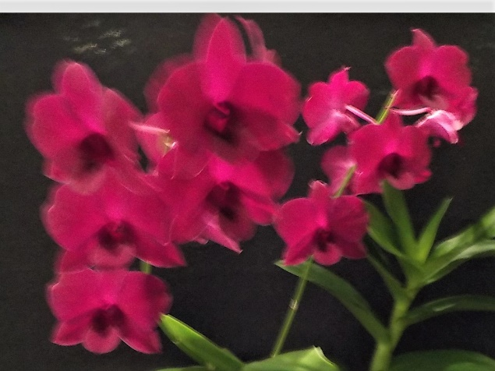

Dendrobium (Singapore) Burgundy Gem Brian Coulton
Novice Section
Species: Lin Barnes
Cymbidium > 90mm:
Cymbidium 60 - 90cm:
Cymbidium < 60mm: Alan Bird
Australian Native Orchid: Min Purtell
Laeliinae > 70cm:
Laeliinae < 70cm:
Paphiopedilum:
Vandaceous: Min Purtell
Pleurothallidinae:
Oncidiinae Alliance: Una Roberts
Seedling:
Miscellaneous:
Fern:
Foliage: Rebecca Baumgartner

Plant of the Night
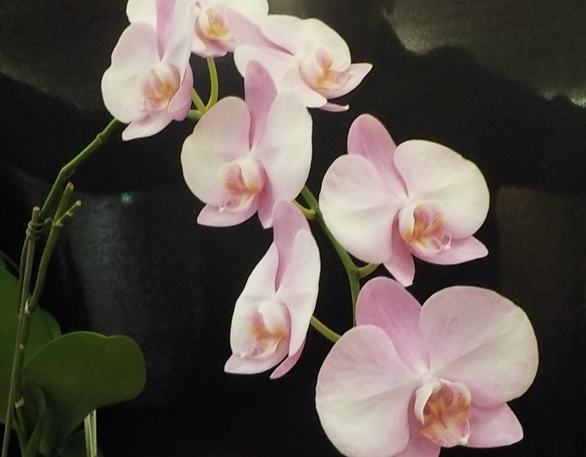
Phal. Othime Miki Min Purtell

BATEMANS BAY ORCHID AND FOLIAGE SOCIETY INC.
DRAFT MINUTES OF THE GENERAL MEETING HELD SOLDIERS CLUB; BEACH ROAD BATEMANS BAY
Monday 2nd April 2018
PRESENT: Members: 25 Apologies: 2 Visitors: 2
President Ron opened the meeting thanking all for coming
MINUTES: The Minutes of the last General Meeting held on Monday 5th March at the Soldiers Club Beach Road Batemans Bay having been circulated be accepted as a true copy.
Moved: Judee Hunt; Seconded: Ken Covington Carried
BUSINESS ARISING: included in the General Business.
1. CORRESPONDENCE:
- Magazines: Orchids Australia, Royal Horticultural Association Victoria Gardeners Gazette,
- Newsletters from Wagga Wagga, Sapphire Coast, Milton/Ulladulla, Canberra, N.S.W, Shoalhaven; EOC.
- Updates about “Orchids in the Foothills” & “Orchids Out West”
- Bank statement & deposit book
- Letter from Soldiers Club confirming dates for 2019.
Out
- BBOFS Newsletters
Moved: Margaret Turner Seconded: Una Roberts Carried
2. TREASURER’S REPORT:
Treasurer Anne-Marie presented:- Opening balance $26,292.50; income $228.08; expenditure $332.00. No unpresented cheques. Closing balance $26,323.58 (includes floats).
Moved: Anne-Marie Collins Seconded: Ray Huddleston Carried
Treasurer also requested payment of any outstanding accounts.
Moved: Anne-Marie Collins; Seconded: Tony Groube Carried
3. GENERAL BUSINESS:
- Next General Meeting – general auction night all items not just orchids
- Sylvia Hawkins was presented with her Life Membership badge and certificate
- Peter Vanest (Member and Guest Speaker) spoke to the Membership about how he grows his Pleoines. They originate in the Himalayas and Taiwan and are easy plants to grow. They have a beautiful flower – Peter passed around photos of some of his plants. They have an extensive root system; however, he uses squat pots or trays, as they prefer shallow soil. His mixture is 50:50 garden soil and bark. He adds organic lifter and cow manure to this mix as well. He suggested that the mix needs to sit awhile (6 – 8 weeks) prior to planting. Bulbs should be repotted each year. Plant out about when start to see movement in the bulbs – usually around early July. Plant into prepared mix with about 2/3 of bulb above the mix. They do not like wet roots so water sparingly. Peter was asked about pests and their management. Can get Mealy Bug occasionally. If so, place a drop of methylated spirits on the leave and allow it to run down into the bulb. This will ensure the bugs are destroyed. Peter also stated that these can be grown in the same part of your shade house as the cymbids as they have the same light requirements. What other orchid can you pot in July and have a flower in October/November. A good website for further information is www.pleione.info/cultivation.
Supper break at 8pm
Return 8.20pm
- Ron spoke about the quality of the plants purchased for raffles. The Committee had discussed options for purchase from different vendors, so a new vendor had been tried. When the plants arrived, Ron spoke with the vendor and requested a refund of half the payment because of the condition of the plants. As yet, this has not been received. Anne-Marie to follow-up.
- Ron spoke about the proposed bus trip to “St Ives Orchid Fair” on August 17th. Marshalls have confirmed that they will provide a 53-seat bus; however, a timetable has not yet been finalized. Bus will cost about $1750. Ron put the motion that “BBOFS run a subsided bus trip to St Ives Orchid Fair on August 17th. BBOFS Members will pay $15.00 and Members of other Clubs will pay $25.00 towards the cost of bus hire. Raffles will be run on both legs of the trip to help with costs.” Seconded by Una Roberts, passed on show of hands with one abstaining.
- The proposed trip again raised the issue of fund raising and Bunnings BBQs. Margaret asked if BBOFS was still being offered the option of dates to do the BBQs. Ron stated we were not as he had informed Krystal that we would not be doing any more. Margaret then asked why it would not be possible for volunteers to do the BBQ without being the facilitor of them? Ron explained about ordering bread and sausages and picking up drinks etc from his place. It was felt that it would be possible for this to happen, just not every month. Ron to follow – up with Krystal regarding the next available date – hopefully in May. For further discussion at Committee.
- As a continuation of the discussion of the Club’s ongoing financial position, and following on from the comment made that our shows run at a loss, the Committee has discussed a reduction in the prize monies at the shows. The committee suggested that the Grand Champion and Reserve Champion prize monies be halved and the Champion monies reduced by $15.00. It was recommended that the Novice prize monies remain unchanged. All agreed on a show of hands.
- This also led onto a discussion relating to how the shows are advertised. A number of options were discussed. It was also suggested to ask the Shire if the banners advertising the events could be placed up earlier. Margaret stated that the letters had been written but not yet posted, so she could change the dates to request that they be displayed for a month rather than the two weeks which is what is currently asked for.
- Ron also informed Members that he had he had received a flyer informing him that Steve Stebbing will be at the Nimmitabel Garden Club plant fair on 21st & 22nd April. Entry is $30.00
- Certificates for Plant of the Night handed out.
- The Committee has agreed that as part of the plant prizes at the Christmas party, Novices who benched during the year would receive an extra plant; the most successful Open & Novice winners would receive a voucher – yet to be determined and Plant of the Night winners would receive a plant for each PON won.
4. RAFFLES: Jona Haargma x 2 (visitor); Ray Huddleston; Judee Hunt; Liz Cleaver; Una Roberts; Margaret Turner x 2; Lin Barnes.
Plant of the Night winners were announced. Results in the Newsletter.
Meeting closed 9.20pm
The next meeting will be on Monday 7th May 2018, At Soldiers Club, Batemans Bay,
Secretary Margaret Turner
THE PICKUP & DROP OFF FOR ST IVES FRIDAY 17TH AUGUST 2018
I would advise all passengers to arrive 5 minutes early at pick up points so all can enjoy maximum time at the Show looking at and buying Orchids. Your support will be appreciated.
Departure times are departure times, we will wait only 5 seconds and then off the bus goes and if all goes well we will run on time for all.

Start pick up at Moruya CWA (off Queen St.) rear car-park Departure 6.30am
Car park at Bowling Club Batemans Bay, the one facing Princess Highway Departure time: 6:50am
Ulladulla big pick-up bus stop opposite the Marlin Hotel. Departure time: 7:35am
Bewong main bus and Coach stop Departure time: 8:15am
Nowra South McDonalds; (02) 4422 1099 arrival time: 8:30am and Departure time: 9:00am
St Ives show ground St Ives: 12:00pm and departure time: 2:30pm
Nowra South McDonalds arrival time: 5:30pm Depart 6.00pm
Bewong main bus and Coach stop Arrival time: 6:15 pm
Ulladulla big pick-up bus stop opposite the Marlin Hotel. Arrival time: 7.00 pm
Car park at Bowling Club Batemans Bay, arrival time: 7:45pm
Moruya CWA (off Queen St.) rear car-park arrival time: 8:15pm

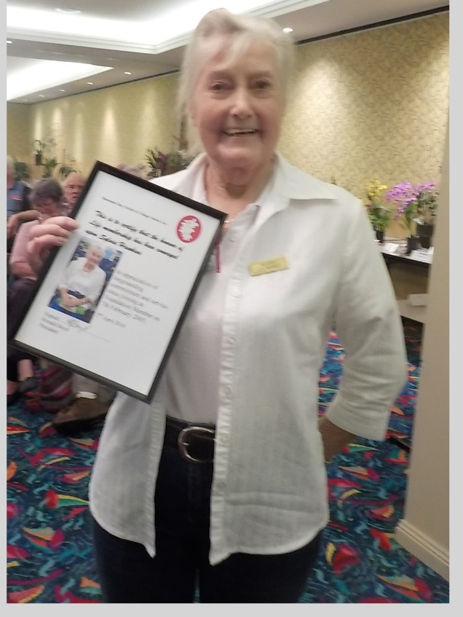
Sylvia with her Life Membership badge and certificate.

Batemans Bay Soldiers Club
Beach Road, Batemans Bay
Major Sponsors of our Club

Bunnings of Batemans Bay
Sponsoring our Club through its BBQs

The cultural information offered in this newsletter is intended as a guide only. Batemans Bay Orchid & Foliage Soc. Inc. cannot be held responsible for any loss or damage that may occur to plants as a result of using this information.

