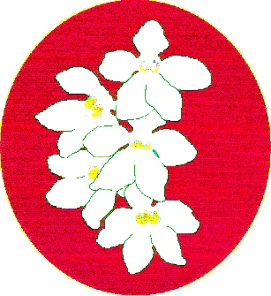
BATEMANS BAY ORCHID AND FOLIAGE SOCIETY INC.
PO Box 3334 Batehaven
NSW 2536
Newsletter - July 2017
President: Ron Boyd 44721934
Vice President: Dorothy Kauffman 44740884
Secretary: Margaret Turner 0409442704
Treasurer: Anne-Marie Collins 0427885186
Committee: Rose Boyd, Lin Barnes, Maureen Anderson, Paula Brown, Brian Perkins, Min Purtell, Jim Purtell.
Web page: www.batemansbayofs.weebly.com
Facebook page: http://www.facebook.com/bbofs/
President report
Hi Members, welcome to our July meeting.
July is finally here, the cold nights have the cymbidium orchids flower spikes growing very quickly and our first show is but a few weeks away.
I am looking forward to the Winter Show. Margaret has the show schedule attached to this month’s Newsletter. Remember to have your plants all setup before bringing them into the show. You can then place them in their class on the Show Bench. If in doubt ask your Show Marshal.
The Committee has been hard at work over the last few months updating the Club’s Constitution to meet the new requirement of the Department of Fair Trading. It and the updated By-Laws are attached to this month’s Newsletter. Please read them and if all is ok we would like to have them passed at our July meeting.
Guest Speaker for July is orchid judge, Peter Stubbs. Peter will talk on preparing your orchid for the shows, or Peter’s way is ‘What the judges hate to see in the way orchids are presented on the Show bench’. This should be a valuable lesson for all of us, not only for shows but also for monthly benching.
For those of you who have not seen the devastation cause by snails and slugs in particular, check out this site https://www.facebook.com/shutterjetphotography/videos/1353758684745430/?fref=mentions
Remember Leanda O’Connor and the team need Cymbidium flowers for posie making for the Winter Show. If you have any flower spikes not quite in show condition, please give Leanda a ring on 44725961 a week or so before the show.
I would like to thank all those members who bring in food for the supper break, which gives us a nice snack along with a cuppa.
At our last Club Meeting you may have noticed we have a larger space for benching. Thanks to Anne-Marie and Lin Barnes who arranged this with the Soldiers Club. This was a much needed boost to our benching area, all due to the support the members are giving by bringing in a lot more flowering orchids, especially the Novice growers which is nice to see.
Good Growing and see you all at the next Club meeting.
Ron
Other items
Item 1: Members can you please save the bases of the 1.25Lt plastic soft drink bottles for the posie making. We will also be looking for flowers and greenery to use in the posie making. Offers gratefully accepted.
Item 2: Supper is to be provided by members with an uneven membership number in July. Thanks to all those who brought in goodies in June.
Item 3. The South and West Regional Show and Conference is on the long weekend in September/October (see dates in diary notes). The theme is “Orchids on the Murray”. A small group of Members have put their hands up to plan the Club’s display for it. There were lots of suggested sub themes put forward at the last General Meeting. Margaret plans to have the photos she has of the river printed as A3 size and members can make comment about which one they prefer and how we can use it for the display. We will be practising this at the upcoming Club Shows. We will also need flowering plants and greenery for the display. Peter has provided us with the judging guide for displays and the judges are aware that there will be a display to judge as well as the individual plants within the display.

Our next meeting:
Peter Stubbs will be speaking about how to present your plants for the Shows and benching. Apparently he gave a similar talk at EOC last month which members found very interesting.
There will also be a discussion relating to nominations for Life Membership.
Plant nomination forms will also be available. The schedule is included in this newsletter.
Included with this newsletter is the updated Constitution and Member By-Laws that the Committee have been working on. Changes are in red type. These will be discussed at the July meeting with the intention of passing them.
Our last meeting:
There was an interesting discussion between members about watering orchid plants during the winter months. The consensus was that it depends on the size of the pots, the conditions under which they grow and the ambient temperatures in the orchid house. If you have any questions, please speak with the experienced growers in the Club and they will help you. See the minutes for further comment.
If you know a Member who usually gets a newsletter and hasn’t this month, it will be because they are no longer financial. Newsletters will not be sent to non-financial Members.
Dates for your Diaries for 2017
June 22 – 24 Royale Orchids Open Days and Fair
June 23 – 25 Mingara Orchid Fair
July 7 – 8 EOC Winter Show, Moruya
July 14 – 16 MUOS Winter Show
July 20 – 22 BBOFS Winter Show
August 11 - 13 Orchid Extravaganza Dural
August 20-22 Sapphire Coast Winter Show
August 18 – 20 St Ives Orchid Fair
August 25-27 Melbourne Orchid Spectacular
September 1 – 2 EOC Spring show Narooma
September 7 – 9 BBOFS Spring Show
September 15 – 17 MUOS Spring Show
September 20 – 22 Sapphire Coast Spring Show
September 29 – 1 October (long weekend) S&W Regional Show & Conference Wodonga (See other items for more information)
October 6 – 8 Southern Orchid Spectacular Caringbah
October 19 – 21 BBOFS Native Show.
November 2 – 4 Sapphire Coast Native Show

In your Orchid House
See comments regarding water. Continue to watch out for bugs who might like the developing cymbidium spikes. Remember also to take the husks off the developing spikes for showing.
Coffee Club continues on the third Thursday of the month from 2-4pm at the Garden Café Botanical Gardens. This is a social get together for Club Members and friends.

Benching
Once again there was a great range of plants benched. The new benching arrangements certainly worked a lot better than the previous month. Thanks to Anne-Maree and Lin for making this work better for Members.
Happy Birthday for July:
Dorothy Kauffman & Joy Guist
and any other members whose birthday falls in July.
Also, I have mislabeled the Novice Plant of the Night winners in the June newsletter. My apologies to Maureen and Una. Hopefully I have corrected them in this newsletter and the corrected certificates will be given out at July meeting.

Open Section
Species: Ray & Gail Huddleston
Cymbidium > 90mm: Liz & Tony
Cymbidium 60 – 90mm:
Cymbidium < 60mm: Brian Coulton
Australian Native Orchid: Liz & Tony
Laeliinae >70mm: Brian Coulton
Laeliinae <70mm:
Paphiopedilum: Ray & Gail Huddleston
Vandaceous:
Pleurothallidinae:
Oncidiinae Alliance: Liz & Tony
Seedling: Liz & Tony
Miscellaneous: Liz & Tony
Fern: Leanda
Foliage: Leanda

Plant of the Night
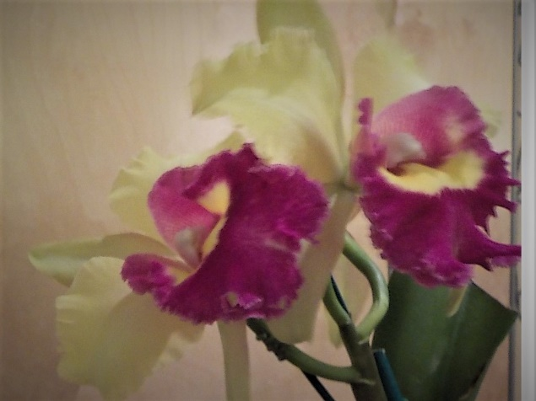
BLC Young Kong “Sun” Brian Coulton

Novice Section
Species: Min Purtell
Cymbidium > 90mm:
Cymbidium 60 - 90cm:
Cymbidium < 60mm: Ann-Maree Collins
Australian Native Orchid:
Laeliinae > 70cm: Jim & Megan Quinlivan
Laeliinae < 70cm:
Paphiopedilum:
Vandaceous:
Pleurothallidinae:
Oncidiinae Alliance:
Seedling:
Miscellaneous:
Fern: Lin Barnes
Foliage:
Plant of the Night
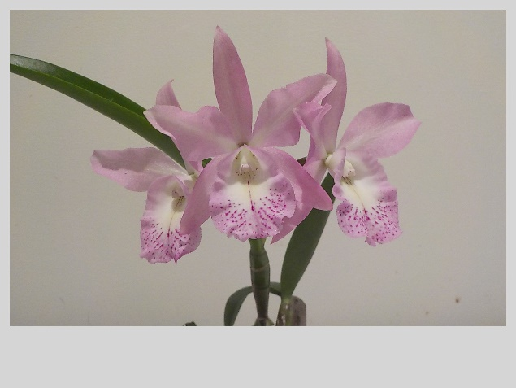
BLC Little Mermaid “Janet” AM/AOC Meg & Jim Quinlivan

BATEMANS BAY ORCHID AND FOLIAGE SOCIETY INC.
DRAFT MINUTES OF THE GENERAL MEETING HELD SOLDIERS CLUB; BEACH ROAD BATEMANS BAY
Monday 5th June 2017
PRESENT: Members: 25 Apologies: 7 Visitors: 0
President Ron opened the meeting thanking all for coming.
MINUTES: The Minutes of the last General Meeting held on Monday1st May at the Soldiers Club Beach Road Batemans Bay having been circulated be accepted as a true copy.
Moved: M. Turner Seconded: Sylvia Hawkins Carried
BUSINESS ARISING: included in the General Business.
- CORRESPONDENCE:
In
- Magazines: Orchids Australia.
- Newsletters from Wagga Wagga, Sapphire Coast, Milton/Ulladulla, Canberra, N.S.W, Shoalhaven; EOC.
- Further information relating to Regional Show
- Mingara Orchid Show flyer
- Notice of Special resolution from OSNSW
Out
- Sympathy Card to Ken Covington
- Order for Winter & Spring Show ribbons
- BBOFS Newsletters
- Letter to Marine Rescue re banner (given to Leanda tonight with cheque)
- Contact with Visitors Centre re hanging banners - Winter 10th – 23rd July; Spring 28th August – 10th September; Native 9th October – 22nd October. All confirmed.
Moved: M.Turner Seconded: Anne-Maree Collins Carried
2. TREASURER’S REPORT:
Treasurer Anne-Marie presented: - Opening balance $18,239.22; closing balance as at 31st May $20,198.96. Income for the month $2902.50; Expenditure $942.76.
Orchids Out West bus trip costs:- seats paid for $950.00; refund entry fee $24.00 (6 people DNA); raffle $298.00 = income $1272.60. Expenditure coach $1650.00; entry fee $212.00; raffle prizes $61.85 = $1923.85 which means the trip was a loss of $651.25.
Moved: Anne-Maree Collins Seconded: Brian Coulton Carried
Treasurer requested permission to pay outstanding accounts.
Seconded Robin Baker Carried
- GENERAL BUSINESS:
- Next General Meeting Peter Stubbs.
- Bus Trip: Ron thanked members for supporting the trip and Min & Lin for helping with selling of raffle tickets. Min & Jim also donated a mini Phalaenopsis for the raffle – thank you. Sylvia on behalf of MUO members who attended thanked Ron for organizing the trip and said how much they had all enjoyed it. Min and Tony on behalf of Shoalhaven & EOC respectively also added their thanks for the opportunity to be on the bus. The other comment that was made was how everyone was on the bus at the requested times, which made the trips there and back more enjoyable.
- Ron explained why he was asking for the Life Membership clause to be added to the Rules for Members (By –Laws). There was some discussion but the members, by show of hands agreed that it should be added.
- Next BBQ at Bunnings is Friday 7th July. Volunteers requested and members responded. This is the first day of the EOC Winter Show.
- Ron then said that he had received nominations for the two (2) vacant committee positions. They were from Min & Jim. Margaret explained that these had been suggested prior to her going overseas last year & when Brian Coulton was unwell. It was not followed up then, but was suggested that a motion be put to the AGM that the committee be increased by two, which was passed. Margaret also reminded the members that the majority of the current Committee Members were novices and stated that she felt the club would be better served by having some experienced growers put their hands up. While this received some support, the suggestion that if people were prepared to help then that should be supported won the day. Min & Jim were duly elected to the committee.
- South and West Regional Show and Conference has provided more information relating to the venue and club requirements. No heating in hall at all, clubs provide own floor covering, backdrop cannot be attached to wall – that is must be free standing, and no capacity to use electrical equipment. Leanda has asked if it is possible to set up practice displays at each of the Shows between now and then (Winter & Spring). This was agreed to. Margaret asked about a budget for the Regional Show and was told about $250.00. Margaret was asked to arrange for the subcommittee to meet. Suggestions for a sub theme were called for from the floor. These included: -barge on the river; ochre cliffs; weir; river winding around the display. Ron spoke about some of the themes at Orchids Out West. Dorothy asked if some photos were available. Lin showed Members present what she had taken.
- Ron then led a general discussion about watering orchids in the winter months. The main information was that the amount of water provided from early Autumn to late Spring depended on the type of orchids that you have, whether or not they are in a covered greenhouse or a shelter that is more solid like a hot house and the size of the pots or if they are mounted. It was agreed that, if possible, to water using rain water and between about 10 and 10.30am as this is best for the orchids. If you have a greenhouse (shade cloth) that is covered during winter, check to see what the temperature reaches in it which will help guide the watering processes. Anything under about 20 degrees should indicate that the orchids will need less water – perhaps about once in two weeks. It was also suggested that if you keep the floor of your greenhouse damp, it will help with humidity which will also help to keep the orchids damp. It also seemed that some of the more experienced growers had their own way of watering which was responding to the needs of the plants. It was also suggested that if you remain unsure about the amount of water required, that using a lollypop stick and pushing it down into the base of the plant would help determine if the root ball in the bottom of the pot was still wet. Obviously, smaller plants/pot will need to be checked more regularly and if the plants are in a “hot” house, they will need to be watered more regularly. It was generally agreed that cymbidiums require little of no water during the winter months.
Supper 8.40pm
Return 9.05pm
h. Min was presented with Committee badges for her and Jim.
4. RAFFLES: Laurine, Ray, Norm, Rebecca, Ken, Min x 3, Lin.
LUCKY DOOR PRIZE: Mitch’s number was drawn out but as he didn’t have his badge it was redrawn with Rebecca Baumgartner (new member) being the recipient.
Plant of the Night winners were announced. Results in the Newsletter.
Meeting closed 9.30pm
The next meeting will be on Monday 3rd July at Soldiers Club; Batemans Bay Secretary Margaret Turner
Novice Plant of the Night (May)
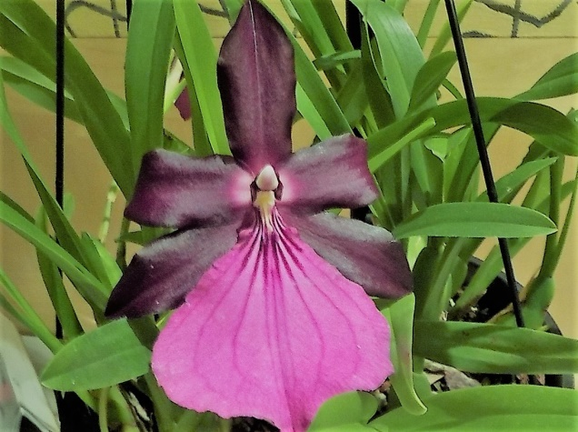
Miltonia Spectabilis var Moreliona Maureen Anderson

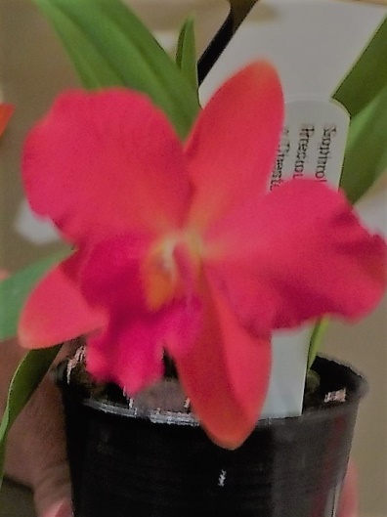
Sophrolae Liocattleya Precious Red Jewel x “Chester Arms” Una Roberts

Soldiers Club
Beach Road
Major Sponsors of our Club

EDWARD RD BATEHAVEN-
FOR ALL YOUR GARDEN SUPPLIES!

Bunnings of Batemans Bay
Sponsoring our Club through its BBQs

The cultural information offered in this newsletter is intended as a guide only. Batemans Bay Orchid and Foliage Society Inc cannot be held responsible for any loss or damage that may occur as a result of using this information.

