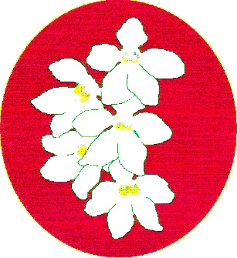
BATEMANS BAY ORCHID AND FOLIAGE SOCIETY INC.
PO Box 3334 Batehaven
NSW 2536
Newsletter – November 2018
President: Ron Boyd 44721934
Vice President: Leanda O’Connor 44725961
Secretary: Margaret Turner 0409442704
Treasurer: Anne-Marie Collins 0427885186
Committee: Rose Boyd, Paula Brown, Min Purtell, Jim Purtell, Ken Covington, Judee Hunt.
Web page: www.batemansbayofs.weebly.com
Email: bbayofs@gmail.com
Facebook page: http://www.facebook.com/bbofs/

President’s Report
Welcome all Members to our next club meeting Monday November 5th 2018, which is also the AGM.
The final Show of the year has come and gone congratulations to all winners especially Robert & Sue Fish for winning the Grand-Champion Native Sarcochilus and Most Successful Open Exhibitor.
Maria Kacarovski for winning the Grand-Champion any other Orchid.
Champion Novice Native Sarcochilus went to Alan Bird. Alan also picked up the Most Successful Novice Exhibitor Trophy as well. Champion any other Orchid went to Brian Pekins and congratulations to all other winners. See full results and photos in the Newsletter.
Many thanks for all members who put orchids in the show. The public appreciate the flowers to look at, in total 220 plants entered.
Thanks to all who helped with the setting up of the show and helping Friday & Saturday with the running of the show.
The November Monday 5th meeting will be our Auction of quality plants by members. Club members can place a reserve price on the plants and get whatever price the final bid is less 10% commission going to the club or can donate all proceeds to the club without putting a reserve on them. Great way to help members get quality plants at a good price.
AGM is on at November meeting and I hope some of you come aboard the committee. We need a strong committee to run our club, its future success is looking very good at the moment. I will be running for President again this year and again I would like all members support.
Our annual Christmas party is on Monday 3rd December. Meeting starts at 6.30pm sharp so we can enjoy our meal at 7pm sharp, see Margaret Turners report in Newsletter.
The results of the Plant of the Night monthly completion results will be given out on the night as well. All novices who entered a plant in the shows or monthly meetings will get 1 plant as encouragement reward. All plants are in 80mm or 100mm pots this year.
For those members who love Paphiopedilums, here is a website I have been buying exhibition type Paphiopedilums flasks from over the last 3 years. I expect a lot to flower in season 2019. I bought 8 flasks this year including 4 flasks of Green / Yellow coloured type. Exciting few years coming up in the flowering department. Check this site out http://cocoa.ego.tw/contentmore.html#menu
Anyone interested in buying flasks in the spring of 2019 or perhaps earlier I recommend you look at Mallie Phallies site http://www.kevalloyd.com.au/malleephallies and have them send you regular updates of flask list from around the world. Keva Lloyd the owner is a very helpful person; I have been buying flasks of many different genera over the last 18 years or so from him with great success.
For those members interested in learning how to deflask orchids, remember our Workshop March 2019 where we will have 4 guest speakers speaking on this subject and Mr Ray Clements from Tinonee Orchid nursery will be talking especially of how he grows his Paphiopedilums.
Sincere thanks to all the members that bring supper along to the monthly meetings of the Society, your efforts are very much appreciated. Your continued support and assistance to the Society will be greatly received.
Karen Ruiz of Mogo Orchids and Fern Nursery are now stockist of all your orchid needs, pots, bark, and fertilizer etc., They have a good range of flowering orchids on sale as well, just give Karen a ring on 44742291.
Good growing
Ron

Other items
- November is an uneven month so Members with an uneven membership number, it is your turn to provide something for supper. Thanks.
- Christmas Party: The Committee has decided to hold the Christmas party as we did last year. That is the December meeting (Monday 3rd) would include the festivities. The idea is that we will have the same rooms that we usually meet in and the restaurant will provide a festive meal in bainmaries. Meats will be ham, pork & turkey with roast veggies potatoes, pumpkin, carrots and broccoli followed by Christmas pudding with custard or Pavlova. Tea & coffee will be available and the bar will be manned from 7pm. The Committee decided that Members would pay $15.00 each and Non -Members full price at $30.00. Also Members are to pay this amount prior to the dinner. Last year, the Treasurer was still trying to get Members to pay for the meal after it was finished. Monies for both membership and Christmas party can be paid electronically if you wish. Bank details are BSB 032681 A/C 191442. In reference please use surname and Christmas and or membership.

Our Next Meeting –
Next meeting is the AGM and orchid only auction. This is an opportunity for members to get feedback on the last years’ activities as well as election of the officer bearers and committee for the next year.
As a reminder, with the update of the Constitution during 2017, it was decided that the Club’s financial year would run from 1st July to 30th June, so the financial report for this current year is for 9 months only.
This night also includes an orchid only auction. Please bring along an orchid or two for the auction. If you choose, you can put a reserve price on the plant or all monies can go to the Club.

Club Members
The BBOFS wishes any Member who maybe unwell all the best for a speedy recovery.
It was good to see Tony at the show looking reasonably well, however he admits there is still a way to go.

Dates to keep for 2019
Interclub workshop in March
Put in your diaries that BBOFS will be running next year’s workshop on 23rd & 24th March 2019. The four speakers invited have all accepted. The Speaker program has been agreed to and is attached to this newsletter for your information. Names can be given to Margaret Turner.

South and West Regional Show
The EOC will be running the Regional Show and Conference in October 2019. It is to be held in Moruya at the Basketball Stadium and the theme is “Nature’s Way”. We will receive more information as it draws closer.

Orchids for sale
Remember that any Member can put orchids on the table for sale at the meetings.
Alan Bird is planning to leave the Bay and as a result would like to sell his orchid collection – mainly cymbidiums. Please contact Alan on 4471 2753 or at 3 Bellbird Drive Maula Bay.
Bill & Joy Guist are also looking to sell their orchid collection. A sale has been arranged at their place on Saturday 3rd November 2018 starting at 2pm. The address is 76 Palana St Surfside. This is planned as a clearance sale due to Bill & Joy’s age and health issues. Orchids include cymbidiums, angraecums and other orchids. This is a cash only sale.
In your orchid house.
Spring has sprung and this recent rain has been very welcome. My water tank is now almost full which means that the orchids should have rain water for the summer months. Watering plants more regularly is now needed. Regular fertilizing is now required but not full strength liquids. Checking and spraying for diseases is also required on a regular basis for the next few months. Now that the show season is over, I will uncover my orchid house.

Dates for your Diary
SCOC Native Show 2 & 3 November Twyford Hall Merimbula

Bunning BBQs
As you are aware, Margaret has nominated BBOFS to again participate in this activity. We have received an offer to run the BBQ on Sunday 9th December. Offers of assistance on this day will be gratefully received. Please let Margaret know if you are able to assist. I still need a person for each of the morning and afternoon shifts. With the new configuration of the BBQ 3 people per shift is enough. Thanks

Benching
Open Section
Species: Liz & Tony
Cymbidium > 90mm:
Cymbidium 60 – 90mm: Margaret Turner
Cymbidium < 60mm:
Aust Native Orchid: Margaret Turner
Laeliinae >70mm: Ron & Rose Boyd
Laeliinae <70mm:
Paphiopedilum:
Vandaceous:
Pleurothallidinae:
Oncidiinae Alliance:
Seedling:
Miscellaneous:
Fern:
Foliage:
Plant of the Night
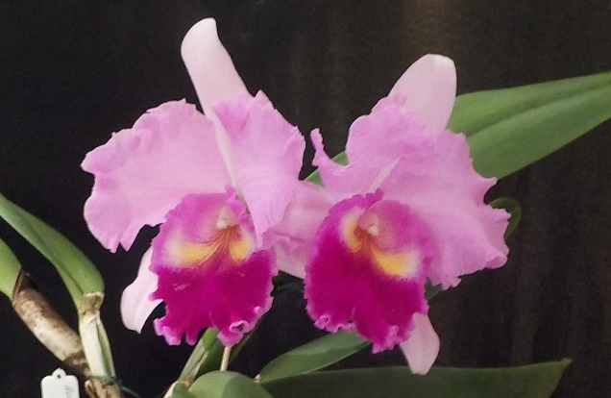
DLC Williette Wong “The Best” Ron & Rose Boyd

Novice Section
Species: Una Roberts
Cymbidium > 90mm: Una Roberts
Cymbidium 60 - 90cm: Una Roberts
Cymbidium < 60mm: Una Roberts
Australian Native Orchid: Alan Bird
Laeliinae > 70cm:
Laeliinae < 70cm:
Paphiopedilum:
Vandaceous:
Pleurothallidinae:
Oncidiinae Alliance:
Seedling:
Miscellaneous:
Fern:
Foliage:
Plant of the Night
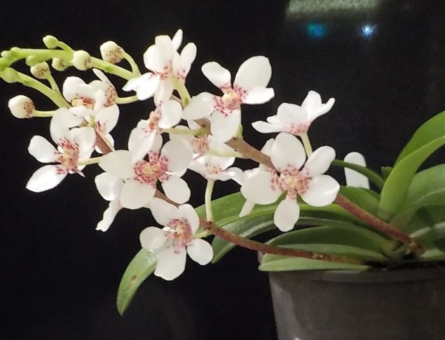
Sarcochulis unknown Alan Bird
BATEMANS BAY ORCHID AND FOLIAGE SOCIETY INC.
DRAFT MINUTES OF THE GENERAL MEETING HELD at the SOLDIERS CLUB; BEACH ROAD BATEMANS BAY
Monday 1st October 2018
PRESENT: Members: 15 Apologies: 8 Visitors: 2
President Ron opened the meeting at 7.32pm thanking all for coming
MINUTES: Accept the Minutes of the last General Meeting held on Monday 3rd September at the Soldiers Club Beach Road, Batemans Bay having been circulated as a true copy.
Moved: Margaret Turner Seconded: Una Roberts Carried
BUSINESS ARISING: included in the General Business.
1. CORRESPONDENCE:
- Magazines: Orchids Australia,
- Newsletters from Wagga Wagga, Sapphire Coast, Milton/Ulladulla, Canberra, N.S.W, Shoalhaven; EOC.
- Response from Stephen Monkhouse regarding attending Interclub Workshop in March
- Open day invitation at Old Court House Museum
- Email regarding inability to attend Interclub workshop in March – Lloyd Edwards
- Acceptance from Ray Clement regarding Interclub Workshop in March
- Gardner’s Gazette from RHS Victoria
Out
- Email to Andrea about and costs of meal for Christmas function
- BBOFS Newsletters
- Email to Jane Wright regarding Stephen Monkhouse intended visit.
Moved: Margaret Turner Seconded: Una Roberts Carried
2. TREASURER’S REPORT:
Treasurer Anne-Marie presented:- Opening balance $28,302.29. Income $1,408.30 Expenditure $1,176.00 Unpresented cheques to the value of $1926.54. Closing balance after unpresented cheques are cleared $26,608.05.
Moved: Anne-Marie Collins Seconded: Leanda O’Connor Carried
Treasurer requested permission to pay outstanding accounts Seconded: Sue Fish
Anne-Marie then presented a yet to be finalized Spring Show reconciliation, which indicated a profit of $155.69. Seconded: Robert Fish
3. GENERAL BUSINESS:
- Next General Meeting AGM and orchid only auction. There would be a short meeting to accept previous minutes, correspondence and financial report for October prior to the AGM, which will commence at about 7.45. During the AGM, all committee positions will be declared vacant and an election will happen to refill these positions. This will be followed by an orchid only auction. Members will be notified of this next week as per the Constitution
- New member badge presented
- Ron offered apology for Tony & Liz’s absence and explained that Tony had some surgery that day in Canberra & the Club wishes him all the best for his recovery.
- Christmas function would be in the same format as last year in these rooms. Margaret has not yet received a menu or costings from the Soldiers Club but will put information in the November newsletter once received.
- Ron thanked everyone who helped at the Spring show in his absence.
- Native show is in two (2) weeks. Once again, helpers are required. In Tony & Liz’s absence Margaret will ask Graham Jackson to be Assistant Show Marshall. To be assisted by Lin, Margaret, Anne-Maree, Min & Leanda. Anne-Maree will ask Mitch if he will do potting demonstration or if he is not available to ask Graham Jackson. Ribbons still have not arrived. Margaret to contact Mrs. Heron to see if they can be delivered to Anne-Marie at Milton Ulladulla meeting next week. Margaret to contact John Stubbs regarding tables at the show.
- Margaret explained that Lloyd Edwards has withdrawn from Interclub workshop in March 2019 for family reasons. However, she has approached Stephen Monkhouse to talk about Zygos, which he has grown for the past 25 years and is a regular speaker in many clubs across bot South Australia and Victoria. He has accepted and Margaret is currently waiting to hear back from him regarding the topics for his talks.
- Now that the Club has its Native Plant License, when selling plants to the public tags must contain the license number as well as the plant name. A list must be kept by the seller and provided to the Secretary of the Club at the completion of the selling period.
- Only a few Members brought in their Growing Experience plants. Most were growing well.
Supper 8.20pm
Return 8.45pm
4. RAFFLES: Anne-Marie, Una x 3, Leanda, Lin, Alan, Brian P, Megan, Yvonne, Judee.
LUCKY DOOR PRIZE: Leanda
Plant of the Night winners were announced. Results in the Newsletter.
Meeting closed 9pm
The next meeting will be on Monday 5th November 2018
At Soldiers Club; Batemans Bay
Secretary Margaret Turner

Batemans Bay Soldiers Club
Major Sponsors of our Club

Champion bench.
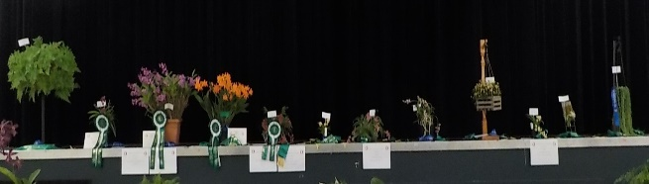

Apia Insurance
Specializing in insurance for the over 55’s
Helping by sponsoring prize monies for our shows

Bunnings of Batemans Bay
Sponsoring our Club through its BBQs
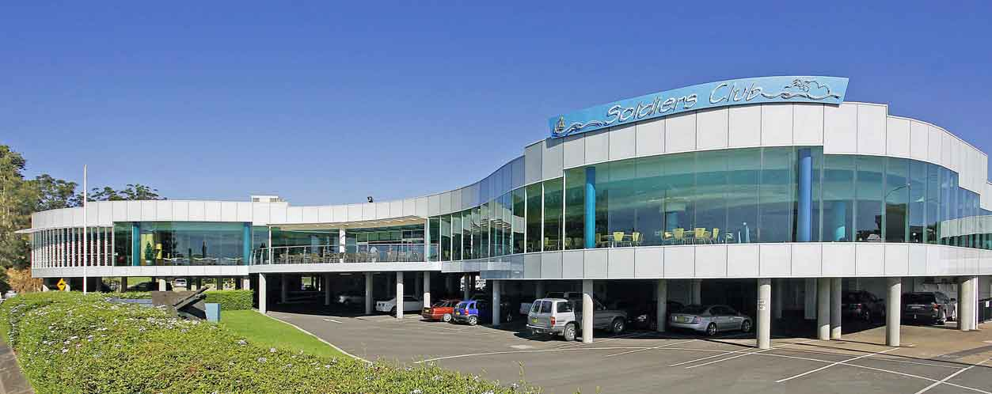

The cultural information offered in this newsletter is intended as a guide only. Batemans Bay Orchid & Foliage Soc. Inc. cannot be held responsible for any loss or damage that may occur to plants as a result of using this information.

NATIVE SHOW 2018 CHAMPION LIST
GRAND CHAMPION AUSTRALIAN NATIVE SARCOCHILUS ORCHID
Robert & Sue Fish
GRAND CHAMPION ANY OTHER ORCHID (Other than Sarcochilus)
Maria Kacarovski
MOST SUCCESSFUL OPEN EXHIBITOR Robert & Sue Fish
CHAMPION SARCOCHILUS SPECIES………………….. Margaret Turner
CHAMPION SARCOCHILUS RED HYBRID……………. . Robert & Sue Fish
CHAMPION SARCOCHILUS PINK HYBRID……………. . Robert & Sue Fish
CHAMPION SARCOCHILUS YELLOW HYBRID……….. Ron & Rose Boyd
CHAMPION SARCOCHILUS HYBRID Robert & Sue Fish
bared, striped, spotted, mottled or marbled patterned types
CHAMPION SARCOCHILUS SEEDLING………………... Robert & Sue Fish
CHAMPION Australian Native Orchid (Other than Sarcochilus) Robert & Sue Fish
CHAMPION NON AUSTRALIAN ORCHID…………..…. Maria Kacarovski
CHAMPION AUSTRALIAN DOCKRILLIA ORCHID …… Brian Coulton
BEST SPECIMEN SARCOCHILUS ORCHID*…………… Robert & Sue Fish
* Minimum of 4 racemes
BEST FERN………………………………… ………………. Una Roberts
BEST FOLAGE…………………………… …………..……. Robert & Sue Fish
CHAMPION NOVICE SARCOCHILUS ORCHID Alan Bird
CHAMPION NOVICE (non Sarcochilus) ORCHID; Brian Perkins
MOST SUCCESSFUL NOVICE EXHIBITOR Alan Bird

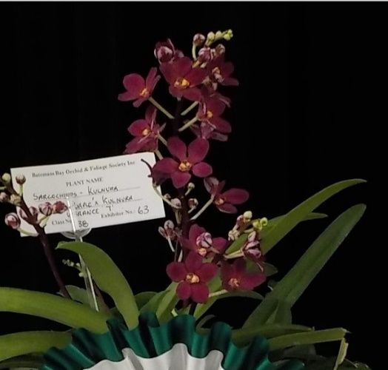 CHAMPION NOVICE SARCOCHILUS ORCHID
Won Alan Bird
Plant Sarc Kulnura Dazzel “Big Apple” X Kulnura Vibrance “7”

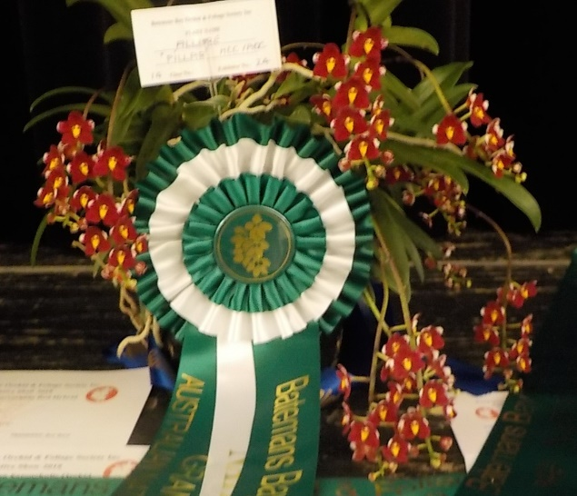
GRAND CHAMPION Australian Native Orchid (Sarcochilus)
Won by Robert & Sue Fish
Plant Name Sarc Allure “Pillar” HCC/AOC

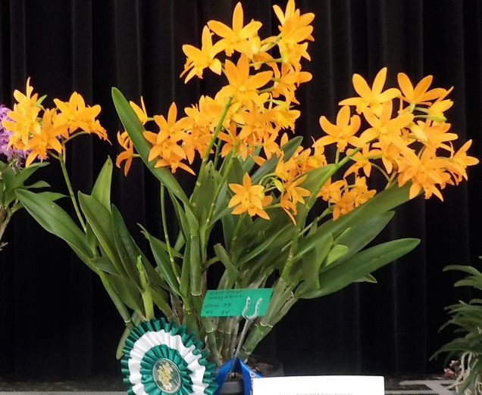
GRAND CHAMPION ANY OTHER ORCHID
Won Maria Kacarovski
Plant Chit Chat Tangerine

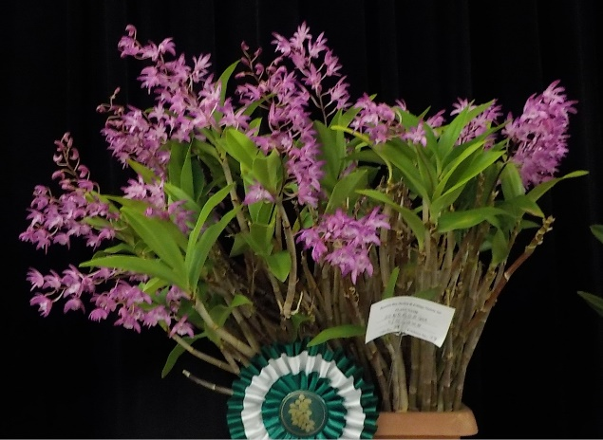

CHAMPION NOVICE (non Sarcochilus) ORCHID
Won Brian Perkins
Plant Den Unknown

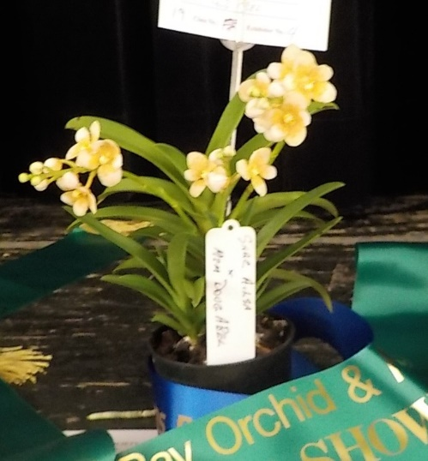
CHAMPION SARCOCHILUS YELLOW HYBRID
Won Ron & Rose Boyd
Plant Sarc Ailsa X mem Doug Abel

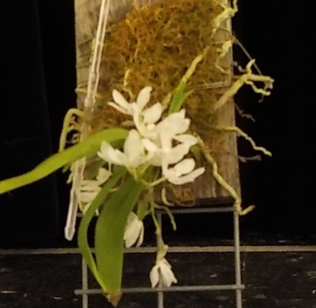
CHAMPION SARCOCHILUS SPECIES
Won Margaret Turner
Plant Falcatus

