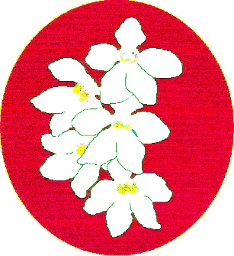
BATEMANS BAY ORCHID AND FOLIAGE SOCIETY INC.
PO Box 3334 Batehaven
NSW 2536
Newsletter – October 2018
President: Ron Boyd 44721934
Vice President: Leanda O’Connor 44725961
Secretary: Margaret Turner 0409442704
Treasurer: Anne-Marie Collins 0427885186
Committee: Rose Boyd, Paula Brown, Min Purtell, Jim Purtell, Ken Covington, Judee Hunt.
Web page: www.batemansbayofs.weebly.com
Email: bbayofs@gmail.com
Facebook page: http://www.facebook.com/bbofs/

President’s Report
Welcome all Members to our next club meeting Monday October 1st 2018
My how time has flown this year, so far a very enjoyable year for me apart from the week in hospital with infected gallbladder and stomach infection, missing the Spring Show was not a good time for me.
I have heard from many Members on how the team pulled together and pulled off a great show and congratulations to all winners especially Karen Ruiz, Grand Champion. Congratulations to all, a wonderful job well done.
Guest speaker last month was well known local grower of Bromeliads, Steve Morgan. Steve gave a great talk on how he grows his Bromeliads. Many secrets were given out freely on the way these wonderful, easy to grow plants, grow under his care. Many thanks Steve.
At our October meeting I would like all Members to bring in their ‘Growing Experience’ plants. Currently running are the Dendrobium Kingianum seedling and also the Dendrobium Johnathon’s Glory while officially finished I would like to see how well the Members have learned to grow this easy to grow and beautiful flowering dendrobium clone. I would like to give feedback to Members on how each of their plants have progressed, after all this a learning way of growing these native orchids.
Remember we have one more show to go and this season seems to be very kind to our Native Sarcochilus Orchids. The setup and judging is Thursday October 18th; open to public Friday 19th and Saturday 20th. I am looking forward to seeing all your plants in flower on the Show bench.
At our September Monday 17th Committee Meeting the team discussed this year’s Christmas party. Looking forward to this wonderful get together. Secretary Margaret has more on this in the Club’s Newsletter.
Sincere thanks to all the Members who bring supper along to the monthly meetings of the Society. Your efforts are much appreciated. Your continued support and assistance to the Society will be greatly received.
Karen Ruiz of Mogo Orchids and Fern Nursery and are now stockist of all your orchid needs, pots, bark, and fertilizer etc., They have a good range of flowering orchids on sale as well, just give Karen a ring on 44742291.
Good growing
Ron

Correction
In the September newsletter under minutes, I reported that during Ron’s talk on viruses he had said the Epson Salts helped to control viruses. However, that is not what Epson salts do. What they do is: Epsom salt helps improve flower blooming and enhances a plant's green leaf colour. It can even help plants grow bushier. Epsom salt is made up of hydrated magnesium sulphate (magnesium and sulphur), which is important to healthy plant growth.
Also by using the Epsom Salts the crooks use it to green up the plants leaves to cover the marking of viruses, especially on soft leaf plants like Cymbidiums
Other items
- October is an even month so Members with an even membership number, it is your turn to provide something for supper. Thanks.
- Sponsorship for the Native show is available. This is the most expensive show for the Club so your sponsorship of prize monies will be appreciated.
- The Club has now received a copy of its licence to sell Native Plants. It has also accepted the ANOS Sydney Group processes for selling Native Orchids to the public. For those of you receiving the newsletter by post, that information is included. Members who receive the newsletter electronically received it the day after the last general meeting.
- Christmas Party: The Committee has decided to hold the Christmas party as we did last year. That is the December meeting (Monday 3rd) would include the festivities. The idea is that we will have the same rooms that we usually meet in and the restaurant will provide a festive meal in bainmaries. At time of writing, I don’t have a menu or cost, however the Committee decided that Members would pay $15.00 each and Non -Members full price. Further information will be provided as it comes to hand. Also Members are to pay this amount prior to the dinner. Last year, the Treasurer was still trying to get Members to pay for the meal after it was finished.

Our Next Meeting –
Please bring along the two (2) growing experience plants that we all have. They are Den. kingianum and Den. Johnathon Glory.

Club Members
The BBOFS wishes any Member who maybe unwell all the best for a speedy recovery.

Dates to keep for 2019
Interclub workshop in March
Put in your diaries that BBOFS will be running next year’s workshop on 23rd & 24th March 2019. The four speakers invited have all accepted. Anne-Marie and Margaret have put a program together, which was approved by Committee. It will be sent to the speakers for confirmation and should be available within the next month.

South and West Regional Show
The EOC will be running the Regional Show and Conference in October 2019. It is to be held in Moruya at the Basketball Stadium and the theme is “Nature’s Way”. We will receive more information as it draws closer.

Orchids for sale
Remember that any Member can put orchids on the table for sale at the meetings.
Alan Bird is planning to leave the Bay and as a result would like to sell his orchid collection – mainly cymbidiums. Please contact Alan on 4471 2753 or at 3 Bellbird Drive Maula Bay.
In your orchid house.
Spring has sprung well mostly anyway although we are still having cold nights. Is it time to think about taking the covers off the orchid house? Watering plants more regularly is now needed, particularly with this wind as it is very drying. Regular fertilizing is now required. Checking and spraying for diseases is also required on a regular basis for the next few months. Do we uncover our orchid houses while still having such cool/cold nights?

Displaying Orchids at shows or club nights
While this information is part of the show schedule, it is worthwhile being reminded of them every so often. Plants should be:
- disease & pest free
- clean & in good condition (wipe leaves with damp cloth)
- in possession of owner for at least 6 months
- observe benching times
- if possible prepare cards prior to arriving at venue
- flowers should be open, fresh & not going over
- give your plant the best chance of being seen (staking, elevation etc)
You can avoid embarrassment by following these simple steps and not having your exhibit unsuitable for display. Show Marshalls or benching officials will offer assistance for the odd “titivation” required but cannot be expected to prepare the whole plant.

Dates for your Diary
BBOFS Native Show 19 & 20 October Soldiers Club Batemans Bay
SCOC Native Show 2 & 3 November Twyford Hall Merimbula

Bunning BBQs
As you are aware, Margaret has nominated BBOFS to again participate in this activity. We have received an offer to run the BBQ on Sunday 9th December. Offers of assistance on this day will be gratefully received. Please let Margaret know if you are able to assist. I still need a person for each of the morning and afternoon shifts. With the new configuration of the BBQ 3 people per shift is enough. Thanks
Benching

Open Section
Species: Margaret Turner
Cymbidium > 90mm:
Cymbidium 60 – 90mm: Liz & Tony
Cymbidium < 60mm: Margaret Turner
Aust Native Orchid: Margaret Turner
Laeliinae <70mm:
Paphiopedilum:
Vandaceous:
Pleurothallidinae: Margaret Turner
Oncidiinae Alliance:
Seedling:
Miscellaneous: Tony & Liz
Fern:
Foliage:
Plant of the Night
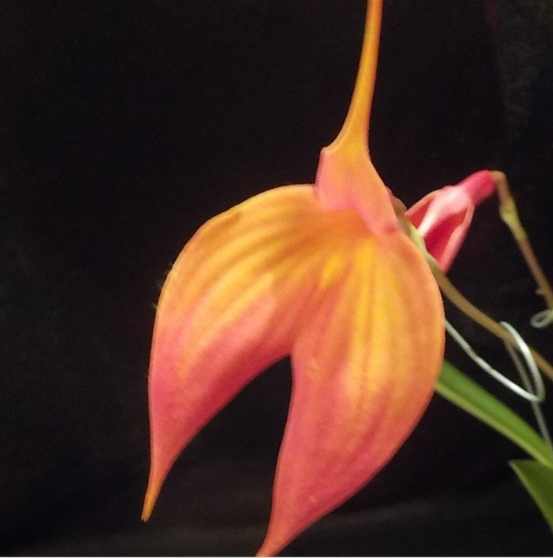
Masd. Falcata Margaret Turner

Novice Section
Species:
Cymbidium > 90mm: Una Roberts
Cymbidium 60 - 90cm:
Cymbidium < 60mm: Alan Bird/Una Roberts (tie)
Australian Native Orchid: Una Roberts
Laeliinae > 70cm:
Laeliinae < 70cm:
Paphiopedilum: Lin Barnes
Vandaceous: Una Roberts
Pleurothallidinae:
Oncidiinae Alliance:
Seedling:
Miscellaneous:
Fern:
Foliage:
Plant of the Night
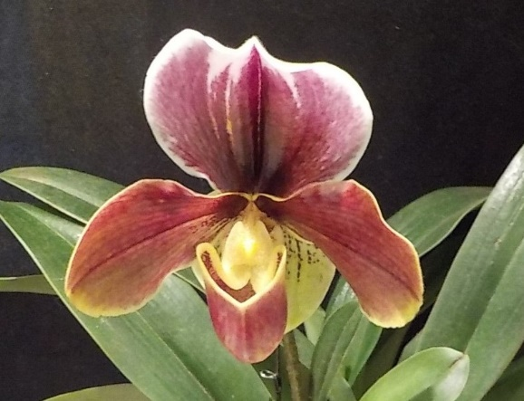
Paph. Redmix x Kiluanna Lin Barnes
BATEMANS BAY ORCHID AND FOLIAGE SOCIETY INC.
DRAFT MINUTES OF THE GENERAL MEETING HELD
SOLDIERS CLUB; BEACH ROAD BATEMANS BAY
Monday 3rd September 2018
PRESENT: Members: 18 Apologies: Visitors: 2
President Ron opened the meeting thanking all for coming.
MINUTES: The Minutes of the last General Meeting held on Tuesday 7th August at the Soldiers Club, Beach Road, Batemans Bay having been circulated be accepted as a true copy.
Moved: Margaret Turner Seconded: Alan Bird Carried
BUSINESS ARISING: included in the General Business.
1. CORRESPONDENCE:
- Magazines: Orchids Australia
- Newsletters from Wagga Wagga, Sapphire Coast, Milton/Ulladulla, Canberra, N.S.W, Shoalhaven; EOC, North Shore.
- Flyer for Canberra show 22nd & 23rd September
- Email from Jane Wright re Stephen Monkhouse coming to this area as guest speaker early next year
- Email from Krystle at Bunnings offering us a BBQ on Sunday 9th December - accepted
- Email from Krystle at Bunnings regarding changes to Policies relating to community groups doing BBQs.
- Australian Orchid Council nomination form for Association Liability Insurance
- Native Plant license
Out
- Email to Peter Cordina (Apia) reminding him of show this week & asking about ongoing sponsorship for 2019 including interclub workshop
- Reminder to Judges for show & schedule
- Response to Australian Orchid Council nomination form completed.
- BBOFS Newsletters
- Sympathy cards to Anne-Marie, Liz & Rod Thomas
Moved: Margaret Turner Seconded: Tony Groube Carried
2. TREASURER’S REPORT:
Treasurer Anne-Marie presented:- opening balance $28074.00 Expenditure $447.10; Income $675.39. Unpresented cheques $1976.54. Current bank balance $28302.29 after unpresented cheques are cleared will be $26325.75. Floats & vouchers remain unchanged. This report included the fiscal report from the recent bus trip to St Ives which incurred a significant monetary loss to BBOFS.
Moved: Anne-Marie Collins Seconded: Tony Groube Carried
Anne-Marie requested permission to pay outstanding accounts.
Moved: Anne-Marie Collins Seconded: Tony Groube Carried

3. GENERAL BUSINESS:

- Next General Meeting; Bring Grow experience plants in – Den. Jonathan’s Glory & Den. kingianum.
- As our native License had arrived, there was further discussion about Members requiring a license to sell plants to the public. Ron and Tony had obtained information from ANOS – Sydney Group in relation to this. This information informed orchid club members that we are able to sell to the public providing documentation of plant names and costs were maintained by the Secretary for at least two (2) years. As a result of this discussion an amendment to the motion passed at the July meeting was put forward. This read “that BBOFS adopt the ANOS – Sydney Group Inc document – Requirements for Plants to be sold to the Public dated 20/8/2018 as their own when selling Native plants to the public.” Moved Ron Boyd Second: Tony Groube. Tony will send information to Secretary who will distribute electronically to Club Members as soon as possible. It will also be available to Members in hard copy at the show. Members who are planning to sell natives at the show are to provide the Secretary with an itemized list of plants that is to include name of plant and their price.
- Spring show is next week. Thanks to all those who have offered to help and help from others is gratefully accepted.
- Tony spoke about a few general rules for displaying orchids at shows and club benching. He handed out a sheet with this information on. He asked for it to be distributed prior to Spring show. It will also be included in the next newsletter.
- Margaret spoke about the publicity for the show nominating business/areas where information has been provided or flyers have been displayed. Banners have been given to Ron to distribute. Could members bring something for morning and afternoon tea please? Posies are to be made at Margaret’s tomorrow.
- Leanda suggested that we need to think about and discuss the Christmas function early. Ron said to hold off on this discussion until next meeting.
- Ron then invited guest speaker – Steve Morgan – the Brom Man to speak. Steve has a range of his bromeliads, which he spoke about in relation to potting mix, watering and fertilizing. Steve reminded members that while Australia has some native bromeliads, the plants from overseas need to be gassed prior to coming into Australia. The mix he uses is iron bark, perlite and charcoal. To fertilize he uses seasol, which has a high potassium level – mixes about 11/2 teaspoons in 16 litres water. He doesn’t water during winter months. He suggested that shade houses be covered in winter to reduce rain access to plants. Also protects them from the cold, as the majority don’t like frosts/cold. Pests are mainly caterpillars and grasshoppers. Steve was asked about when to remove pups and he stated they need to be about 1/3 to ½ the size of the mother plant.
Supper break 9pm
Return 9.25pm
4. RAFFLES: Alan Bird, Megan Quinlivan, Margaret Turner x 2, Leanda O’Connor, Una Roberts, Anne-Maree Collins x 2, Lin Barnes x 2, Liz Cleaver.
LUCKY DOOR PRIZE: Una Roberts
Plant of the Night winners were announced. Results in the Newsletter.

Meeting closed 9.45pm
The next meeting will be on Monday 1st October
At Soldiers Club; Batemans Bay
Secretary Margaret Turner

Championship Prizes Spring Show 2018

Grand Champion of the show: Karen Ruiz

Reserve Champion of the show: Robert & Sue Fish

Most Successful Exhibitor of the Show: Open Liz Cleaver & Tony Groube

Champion Cymbidium 90 mm and over: Liz Cleaver & Tony Groube

Champion Cymbidium 60 to 90 mm: Min Purtell

Champion Cymbidium up to 60 mm: Gordon Marion

Champion Laeliinae Alliance: Brian Coulton

Champion Australian Native Species / Hybrid : Karen Ruiz

Champion Paphiopedilum: Leanda O’Connor

Champion Phalaenopsis: Robert & Sue Fish

Champion Vandaceous Orchid: John Stubbs

Champion Pleurothallid Alliance: Peter & Laurine Vanest

Champion Orchid, any other Genera: Jean Swindley

Champion Oncidiinae Alliance: Brian Coulton

Champion Australian Native Seedling Orchid: Gordon Marion

Champion any other Seedling Orchid: Robert & Sue Fish

Champion Species Orchid: Karen Ruiz

Champion Specimen Orchid of the show: Paula & Michael Brown

Champion Fern: Tony Groube & Liz Cleaver

Champion Foliage: Ken Covington

Champion Novice: Min Purtell

Most Successful Novice Exhibitor of the Show: Min Purtell

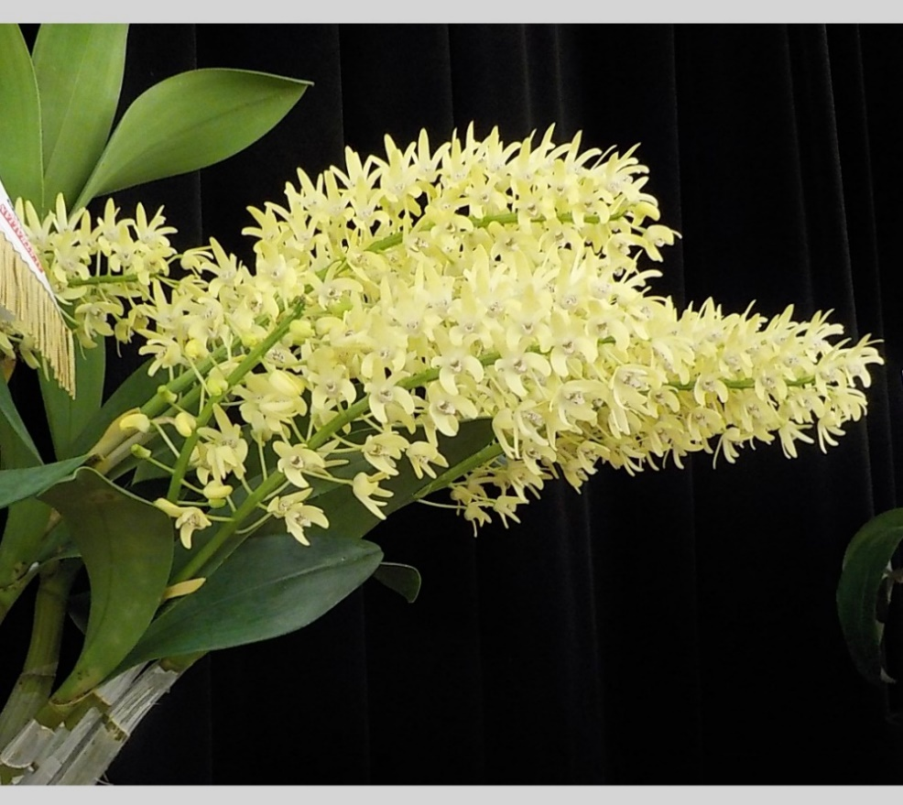
Karen Ruiz
Dendrobium Speciosum Alliance
Compactum ‘Red Factor’ X Curvicaule

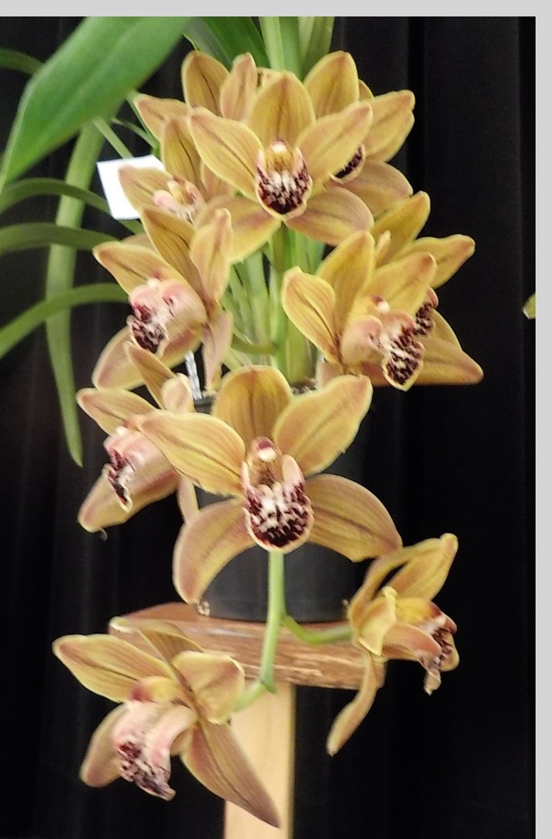
Min Purtell Champion Novice
Cymbidium 60 – 90 Ron Wiley ‘Red Grouler’ X Devonianum ‘Royale’
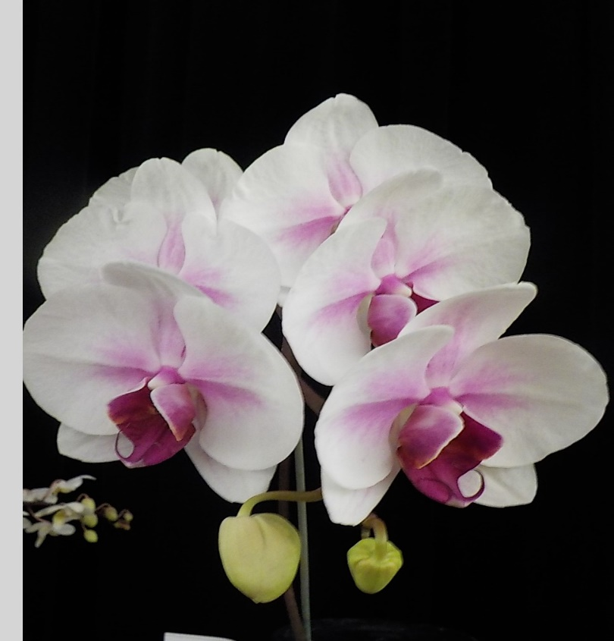
Robert & Sue Fish Reserve Champion
Phal. Mount Lip
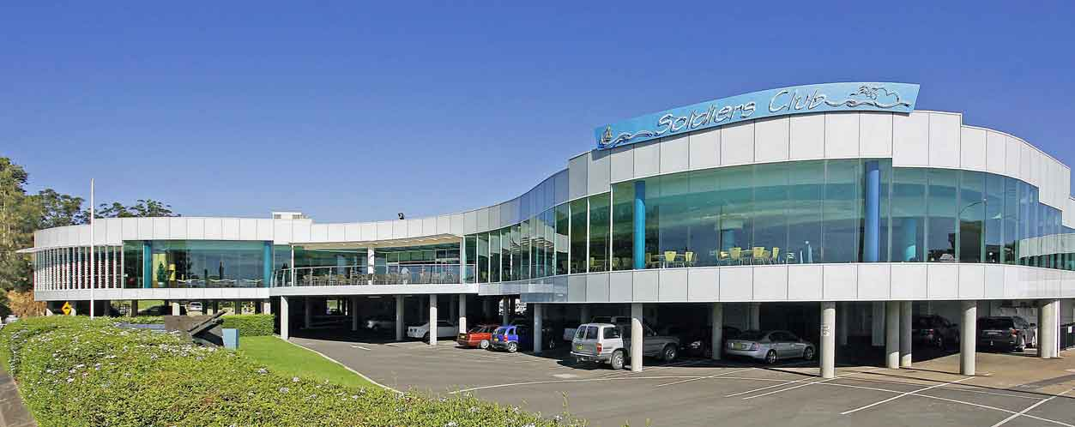
Batemans Bay Soldiers Club
Major Sponsors of our Club
Apia Insurance
Helping to sponsor prize monies for our shows

Bunnings of Batemans Bay
Sponsoring our Club through its BBQs

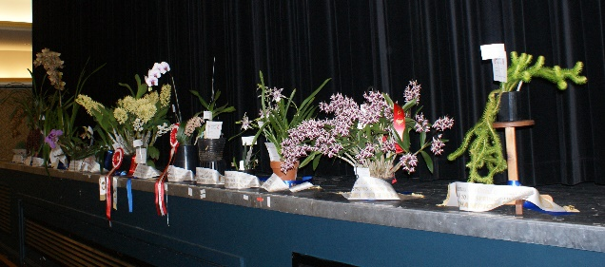

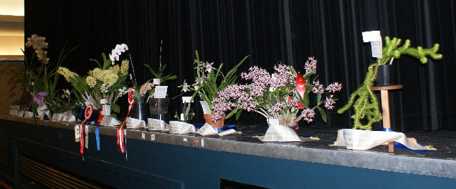
A couple of photos of the champions table which was the stage with the black curtain drawn.

The cultural information offered in this newsletter is intended as a guide only. Batemans Bay Orchid & Foliage Soc. Inc. cannot be held responsible for any loss or damage that may occur to plants as a result of using this information.

