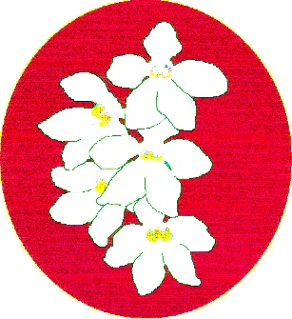
BATEMANS BAY ORCHID AND FOLIAGE SOCIETY INC.
PO Box 3334 Batehaven
NSW 2536
Newsletter - October 2017
President: Ron Boyd 44721934
Vice President: Dorothy Kauffman 44740884
Secretary: Margaret Turner 0409442704
Treasurer: Anne-Marie Collins 0427885186
Committee: Rose Boyd, Lin Barnes, Maureen Anderson, Paula Brown, Brian Perkins, Min Purtell, Jim Purtell.
Web page: www.batemansbayofs.weebly.com
Email: bbayofs@gmail.com
Facebook page: http://www.facebook.com/bbofs/

President report
Hi Members, welcome to our October meeting.
At our October meeting a special meeting is required before general business to discuss and move the Club’s updated Constitution and By-laws. Secretary Margaret Turner sent out a message advising that the special meeting has been called.
Interested Members attended a meeting on Tuesday 12 September to help update both documents. This took many hours updating both documents.
Also at this meeting please bring in our growing experience plant and Club Emblem plants Dendrobium Johnathon’s Glory ‘Dark Joy’ and Sarcochilus falcatus to see how they are faring. I will give them a good look over and check them out, please have a code or name on your plants.
Any new Member who has not received these plants, can acquire one at the October meeting.
Our Native Show is not too far away, setup 19th October and show open to public Friday 20th and Saturday 21st. Schedule with newsletter. Keep a good eye on your Sarcochilus plants as they should be putting up flower spikes by early October.
Remember the Club has now 2 Grand-Champions at the Native Show, Grand-Champion Sarcochilus for all of the Sarco. lovers and Grand-Champion for any other genera. Great chance for all members to pick up the big one so get into looking after and dressing up your favourite orchids.
For those members who cannot help out at Bunnings BBQS, another good way to support the club financially is to sponsor Champions classes at our Shows. These will be read out at the presentation of each championship.
Good Growing and see you all at the next Club meeting.
Ron
Other items
Item 1: Members can you please continue to save the bases of the 1.25Lt plastic soft drink bottles for the posie making.
Item 2: Supper is to be provided by Members with an even membership number in September. Thanks to all those who brought in goodies in August.
Item 3. Due to a number of reasons, BBOFS will now not be mounting a display at the South & West Regional Conference and Show (S&WRCS). However, some members will still be attending. It is still planned to mount a display at the Native Show. There were some very positive comments received from the judges at the Spring show, so well done to Leanda & her team. More practice will ensure the standard of the display will be high by the time the next S&WRCS comes around in 2019. That one is being planned by EOC.

Our next meeting:
Please bring in your Growing experience plants for review and discussion. They are the Club Emblem Sarcochilus Falcatus and the Dendrobium Johnathon’s Glory ‘Dark Joy’.
There will also be a Special Meeting to ratify the new Constitution and By-Laws. A small group of Members meet Tuesday 12th at the Soldiers Club to finalize these documents. Thanks to the Members who attended.
Happy Birthday for October
To Sue Fish and any other members whose birthday falls in September.

Our last meeting:
See the minutes for a summary of Ron’s talk about Cattleyas.
Dates for your Diaries for 2017
Tri-Club Fun Day at Mogo Orchid and Fern Nursery: please note that this activity has been postponed.
September 29 – 1 October (long weekend) S&W Regional Show & Conference Wodonga (See other items for more information)
October 6 – 8 Southern Orchid Spectacular Caringbah
October 19 – 21 BBOFS Native Show.
November 2 – 4 Sapphire Coast Native Show
Welcome to New Members.
It is great to see our new Members benching plants at Club meetings and doing well.
In your Orchid House
Normally, we would be talking about taking covers off the orchid house by now, but with these colder nights it may be best to leave them in place for a bit longer.
Our Native Show is not far away, so start preparing your orchid spikes for benching, remembering Peter Stubbs’ guidelines.
Repotting season is also starting, so check your supplies and talk to Dot at Grumpy’s Shed.
Coffee Club continues on the third Thursday of the month from 2-4pm at the Garden Café Botanical Gardens. This is a social get together for Club Members and friends.
Benching
Once again there was a good range of plants benched. Thanks to all Members who bring plants in each month.
Open Section
Species: Margaret Turner
Cymbidium > 90mm: Brian Coulton
Cymbidium 60 – 90mm: Liz & Tony
Cymbidium < 60mm: Brian Coulton
Australian Native Orchid: Brian Coulton
Laeliinae >70mm:
Laeliinae <70mm: Ron & Rose Boyd
Paphiopedilum:
Vandaceous:
Pleurothallidinae:
Oncidiinae Alliance: Brian Coulton
Seedling: Liz & Tony
Miscellaneous: Robin Baker
Fern:
Foliage: Leanda O’Connor

Plant of the Night
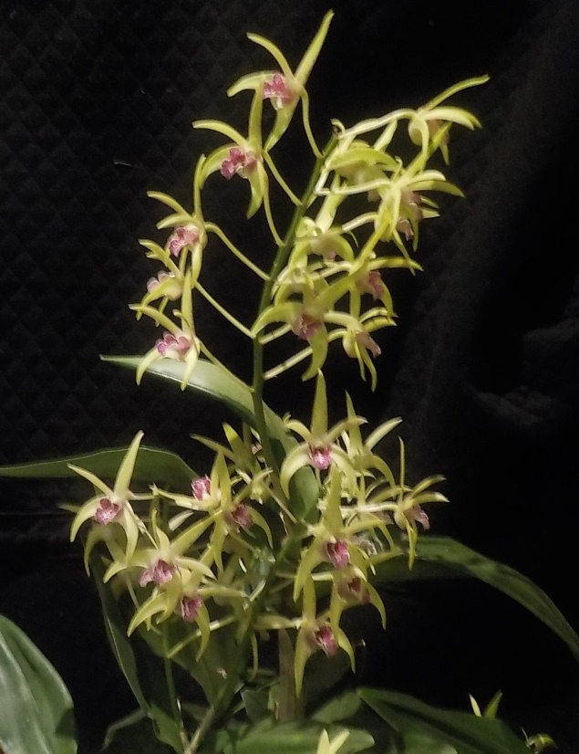
Den. Balnarring Brian Coulton
Novice Section
Species: Anne-Marie Collins
Cymbidium > 90mm: Alan Bird
Cymbidium 60 - 90cm:
Cymbidium < 60mm:
Australian Native Orchid: Maureen & Noel Anderson
Laeliinae > 70cm:
Laeliinae < 70cm:
Paphiopedilum:
Vandaceous:
Pleurothallidinae:
Oncidiinae Alliance: Ken Covington
Seedling:
Miscellaneous:
Fern:
Foliage: Ken Covington
Plant of the Night
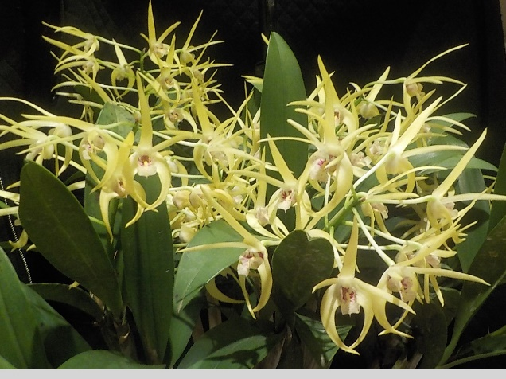
Den. Hilda Poxen x Gai Ellen x Peewee x Graham Hewitt. Maureen & Noel Anderson

BATEMANS BAY ORCHID AND FOLIAGE SOCIETY INC.
DRAFT MINUTES OF THE GENERAL MEETING HELD AT THE SOLDIERS CLUB, BEACH ROAD, BATEMANS BAY
Monday 4th September 2017
PRESENT: Members: 23 Apologies: 8 Visitors: 0
President Ron opened the meeting thanking all for coming.
MINUTES: The Minutes of the last General Meeting held on Monday 7th August at the Soldiers Club Beach Road, Batemans Bay having been circulated be accepted as a true copy.
Moved: Margaret Turner Seconded: Maureen Anderson Carried
BUSINESS ARISING: included in the General Business.
- CORRESPONDENCE:
Out
- Letter to secretary of South & West Regional show informing them that BBOFS would not be putting on a display
- Letter & schedules to judges for spring show
- Publicity for show to various news/radio outlets.
- Letter to Paul Biddlestow reminding him of show
- Notification from Tinonee that they would be at South & West Regional show
- Sympathy cards to Elaine Kelly and Robert & Sue Fish

In
- Magazines: Orchids Australia, Australian Orchids
- Newsletters from Wagga Wagga, Sapphire Coast, Milton/Ulladulla, Canberra, N.S.W, Shoalhaven, EOC.
- Response from Paul informing us of his inability to attend, but stating the Keith Kauffmann would attend in his place.
Moved: Margaret Turner Seconded: Leanda O’Connor Carried
2. TREASURER’S REPORT:
Treasurer Anne-Marie presented report:-Opening balance $15,961.25. Income for month $790.00; expenses $714.92. Outstanding cheques $447.38. Closing balance $15,589.45. Anne-Marie also provided a list of what the club had used the Bunnings vouchers for. Instead of taking vouchers for doing the Fathers’ day activity Anne-Marie negotiated donations of a large esky and another trolley for BBOFS club use.
Moved: Anne-Marie Collins, Seconded: Liz Cleaver Carried
Anne-Marie requested permission to pay outstanding invoices – seconded Robin Baker Carried
3. GENERAL BUSINESS:
- Next General Meeting: ratification of constitution and by-laws following meeting at Soldiers Club at 1pm on Tuesday 12th September and review of grow experience plants – club emblem & Johnathon’s Glory.
- Ron gave new Member Barry his plants for the growing experience
- Members were notified that some Members who were planning to attend South & West Regional Conference and Show were now unable to do so. As a result, BBOFS would not be able to mount a display. Secretary to notify Albury – Wodonga of this.
- Tony informed the meeting of a change of date to the Tri club day at Mogo Orchid and Fern Nursery. It is now Tuesday 26th September from 11am. Please bring own chairs.
- Fathers’ Day activity at Bunnings went well. A reasonable amount was received in the donations box. Amount to be finalized for next meeting. BBOFS has BBQs in November and December as well as 22nd September. Volunteers called for and received.
- Ron thanked Anne-Marie for organizing to receive the esky and trolley in lieu of vouchers for the Fathers’ Day activity.
- Ron reminded members of the Spring show the next weekend and thanked those members who assist in advance. Plant names slips and benching lists were available during the evening.
- Ron then spoke about growing Cattleyas, which are cool growers. He grows mostly mini cats. He uses an open mix like medium size bark, which allows good drainage from the pots, as they do not like wet roots. He fertilizes with 9-month slow release annually, and spreads some lime at the same time. He also uses a weak solution of liquid fertilizer like organic life every two (2) weeks during the growing season, which is spring to autumn. In spring, repot as necessary as the new growth is seen. Irregular watering will be required during winter. Ron also had a PowerPoint presentation of photos of some of his cattleyas and some from the net.
Supper break 8.20pm
Return 8.45pm
4. RAFFLES: Ron; Lin; Brian P; Norm x 3; Robin x 2; Mitch; Paula; Anne-Marie.
LUCKY DOOR PRIZE: Lin Barnes
Plant of the Night and section winners were announced. Results in the Newsletter.
Meeting closed 9pm
The next meeting will be on Monday 2nd October
At Soldiers Club; Batemans Bay
Secretary Margaret Turner

Soldiers Club
Beach Road
Major Sponsors of our Club
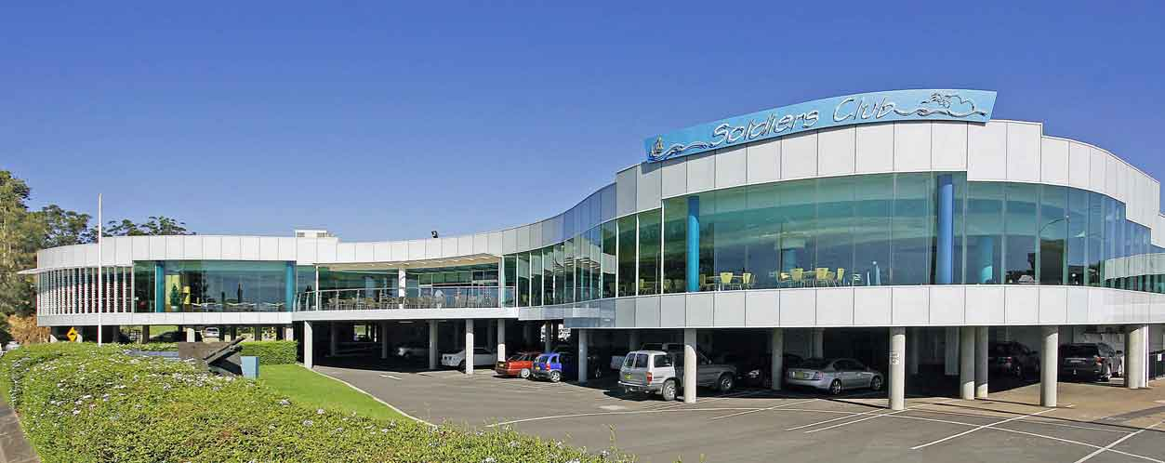

EDWARD RD BATEHAVEN-
FOR ALL YOUR GARDEN SUPPLIES

Bunnings of Batemans Bay
Sponsoring our Club through its BBQs

The cultural information offered in this newsletter is intended as a guide only. Batemans Bay Orchid and Foliage Society Inc cannot be held responsible for any loss or damage that may occur as a result of using this information.

