President:
Anne-Marie Collins
0427885186

Secretary:
Margaret Turner
0409442704

Treasurer:
Leanda O’Connor
0475848832

Club email:
bbayofs@gmail.com

Club website & Facebook:
http://batemansbayofs.weebly.com/
hppts://www.facebook.com/bbofs/?fref=ts

Show dates for 2023
Winter Show July 15th & 16th.
Spring Show September 2nd & 3rd
Native Show October 21st & 22nd

Batemans Bay Orchid & Foliage Society Inc

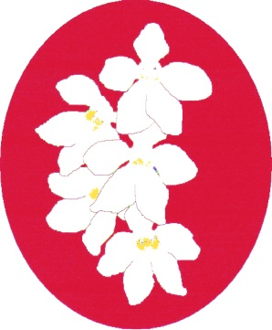

Membership Application

Batemans Bay Orchid & Foliage Society Inc Membership Application

Please tick the appropriate boxes.
New Member Renewal of Membership
Badge Fee is $10 which covers the cost of your name badge which is additional to the membership fee. Membership is from 1st January each year. If you join between 1st July and 31st December, you pay half fee as well as the badge fee.
I / we hear by apply to become a member/s of the above named incorporated association. In the event of my/our admission as a member, I/we agree to be bound by the rules of the association.

Badge fee $10.00
Membership Fees:
Single Rate: $10.00
Couple Rate: $15.00
Junior $5.00

Newsletter Postage $5.00

Surname:..............................................................
First Name...........................................................
Address................................................................
………………………….Post Code…………..
Phone…………………………………………..
Email Address…………………………………

Payment Details:
Cash Cheque Money Order
Amount enclosed: $...................................... Cheques and money orders must be payable to:
The Batemans Bay Orchid & Foliage Society Inc.

PO BOX 3334, Batehaven NSW 2536
To be signed by Treasurer or appointed person.
Name:............................................................

Membership Number:

Bank Westpac – Bateman’s Bay
BSB: 032-681
Account: 191442
In Reference, add your surname & that payment is for membership.

Batemans Bay Orchid & Foliage Society meets on the 1st Monday of the Month, at 7.00pm. (Except January) The meetings are held at the Soldiers Club, 2 Beach Rd. Batemans Bay. To become a member, just come along and join us & fill out the membership form.
This is a social gathering for orchid enthusiasts.
If you are interested in Orchid growing and would like to know more, come along to a meeting.
Our meetings consist of benching flowering orchids along with regular guest speakers.
A light super is provided. There is also a raffle and a lucky badge number draw.
Throughout the year social gatherings like picnic days are arranged. We have a monthly newsletter bringing you up to date with the activities of the club. There is also a Floral Art group within the club which meets on the 4th Monday of the month except December..
And of course the end of year Christmas Party.
If you have any questions at all, please do not hesitate to contact the club.

