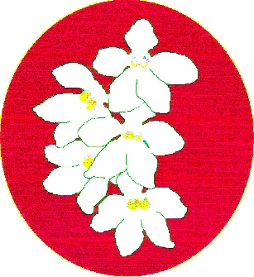
BATEMANS BAY ORCHID AND FOLIAGE SOCIETY INC.
PO Box 3334 Batehaven
NSW 2536
Newsletter – March 2021
President: Anne-Marie Collins 0427 885 186
Vice President: Ken Covington 0418 281 637
Secretary: Margaret Turner 0409 442 704
Treasurer: Leanda O’Connor 4472 5961
Committee: Ron Boyd, Megan Quinlivan, Una Roberts
Web page: www.batemansbayofs.weebly.com
Email: bbayofs@gmail.com
Facebook page: http://www.facebook.com/bbofs/

President’s Report
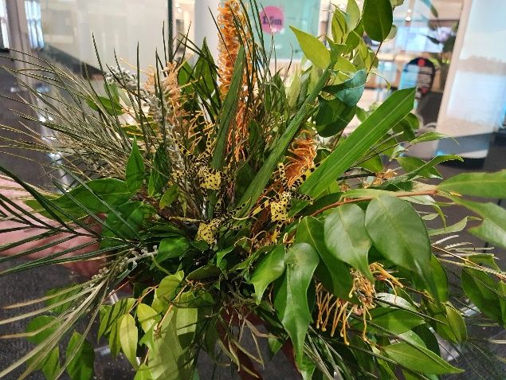
First evening of Foliage display/judging. This is Anne-Marie’s display, which included the only orchids that she had out.

The year is already racing away and so far, so good.
At our second committee meeting for 2021, we worked on final details for the Sweet 16th Anniversary Luncheon. If you are coming, you need to let Margaret know and pay your $10 deposit. We have the cake organised, which is always an important part of the party. The cut-off date is in this newsletter and time is flashing past.
Our 2021 Calendar is full and most things are confirmed now. Floral Art still needs themes added to their times. April’s will be on a Mother’s Day theme and February’s is the Sweet 16th Anniversary theme. However, March’s is a scavenger hunt – sounds like fun.
The Bunnings B.B.Q. on Saturday, 13th February, was a great success. Thank you to Margaret [organiser], Ken and Robert [chefs], Sue, Una, Ian, Leanda and Nola [ excellent servers and workers]. They did a fantastic job and I appreciate their hard work. At our next one, it would be lovely if others would volunteer – it isn’t hard. You will be given onsite training. Leanda even said it was fun.
At our February Meeting there was space for a new section --- Floral Art Exhibits. It is one section, not divided into Novice and Open. There were 2 exhibits, one on display and the other in the competition. They both looked lovely and we hope next month there will be more. The exhibit does need to have a live orchid in it, preferably predominately orchid flowers, but they are still rather scarce at this time of the year. Please, give it a go and show us your talents.
Our speaker in March is Jane Wright, A.C.T. orchid judge. She will be speaking on Peru and Ecuador orchids in situ, plus showing us slides of them. This will be followed by her talk on pests and diseases in our local orchids. So if you have problems, bring your questions and Jane may well have the answers. Most importantly, Jane will be bringing a variety of orchids for sale – so start saving now.
I am looking forward to seeing more members at our March meeting, so come along and enjoy your hobby, socialise and learn.
Anne-Marie Collins
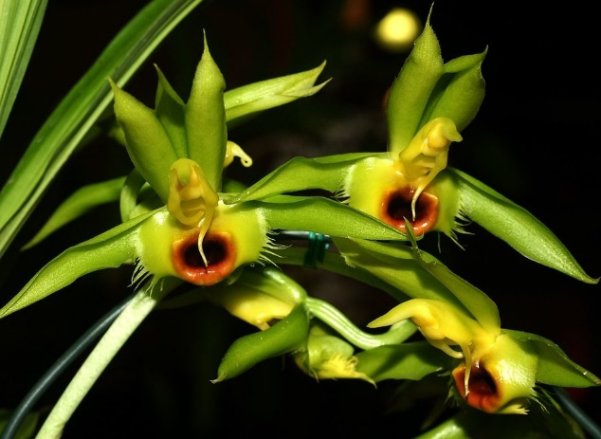
Catasetum
Our Next Meeting –
- Our guest speaker is Jane Wright from Canberra. Jane is well known to us, as a grower of renown, a speaker and a judge.
She has told us that she will be bring some plants for sale as well as talking about 1) Peru/Ecuador - orchids in situ and
2) Pests & Diseases in Our Orchids.
She is also bringing a Catasetum to go on our raffle.
Meeting Protocols Reminder
• Please do not come to the meeting if you do not feel well.
• Please maintain a distance of 1.5 meters from each other at all times, keeping to your seat as much as possible.
• You must sign in, both at the club and the meeting,
• Do not congregate to ensure social distancing is maintained.
• Please use hand sanitizer as you enter, before you do Popular Vote and before supper.
• Do not engage in any activities that involve physical contact, including hand shaking and hugging or multiple people having contact with equipment.
• Feel free to wear a mask if you wish.

Membership Renewals
Memberships are now due and need to be paid by our April meeting. These can be paid at either the March or April meetings or it can be paid directly into our Westpac account either by visiting the bank or using Electronic Funds Transfer (EFT).
Membership costs are as follows:
Single rate:- $10.00
Couple/dual rate:- $15.00
Junior (under 16):- $5.00
If receiving newsletter as hard copy please add $5.00 to above costs.
New members will also pay a joining fee of $8.00 that covers the cost of the name badge. Bank details are as follows:
Bank Westpac – Bateman’s Bay
BSB: 032-681
Account: 191442
In Reference, add your surname & that payment is for membership.
Members who do not pay their subs are ineligible to vote at meetings, are unable to show plants at general meeting.
From the Committee
Sweet 16 Luncheon
The Bubble at the Soldiers Club can seat between 35 and 40 people now. It is most important that we know how many members wish to attend, so please let Margaret know, either by phone, email or at the meetings. A $10 deposit is required to ensure you a seat. Non-members who attend with a member need to pay for their own lunch.
A cake has been ordered and lucky door prizes organised.

A Complete Guide to Native Orchids of Australia by David Jones.
Anne-Marie has received this book and she will have it at the March meeting.

Floral Art Group
Will be doing table centre pieces for our Sweet 16 party.

Club Members
The BBOFS wishes any Member who may be unwell all the best for a speedy recovery.

In Your Orchid House
Once again we are in that time where we get a little bit of rain, but depending on what we have our orchid houses covered with, will depend on how much gets onto the plants. Some experts will say that watering in the late afternoon or early evening when the heat of the day has passed is best others will still say water in the morning. However, watering during the heat of the day is not recommended as it may cause the new growths to rot. Having said all of that, on a really hot day it is probably good to keep the floor of your orchid house damp as this helps keep the atmosphere more buoyant. After a really hot day most plants appreciate a water after the sun has sunk a bit and it has started to cool down.
Obviously, this is still the growing season for plants so regular fertilization is a good idea for all genre but strength and regularity of feeding will depend on the needs of the plant.
With all this water about, keep a close eye out for pests and manage as needed.

Diary Dates
July
3 & 4 MUOS Winter Show Civic Centre Ulladulla
9 & 10 EOC Winter Show CWA Hall Moruya
17 & 18 BBOFS Winter Show Soldiers Club Batemans Bay
August
13 – 15 Sapphire Coast Winter Show Twyford Hall Merimbula
21 & 22 EOC Spring Show Leisure Centre Narooma
September
4 & 5 BBOFS Spring Show Soldiers Club Batemans Bay
11 & 12 MUOS Spring Show Civic Centre Ulladulla
October
2 & 3 South & West Regional Show Wagga Wagga (TBC)
23 & 24 BBOFS Native Show Soldiers Club Batemans Bay (new dates)
29 & 30 Sapphire Coast Spring Show Twyford Hall Merimbula
November
1st AGM & Orchid auction
December
6th Christmas Party venue TBC
EOC is planning on running the usual March workshop at some stage during the year, so keep your eyes open for more information here. (see minutes)

Benching
There was a reasonable display of plants in the Open section, however the plant of the night for novice looked very lonely on the bench.

Open Section
Species: Margaret Turner
Cymbidium > 90mm:
Cymbidium 60 - 90mm:
Cymbidium < 60mm:
Aust Native Orchid:
Laeliinae >70mm:
Laeliinae <70mm:
Paphiopedilum:
Vandaceous:
Pleurothallidinae:
Oncidiinae Alliance: Liz & Tony
Seedling: Liz & Tony
Miscellaneous: Liz & Tony
Fern: Margaret Turner
Foliage: Margaret Turner

Plant of the Night
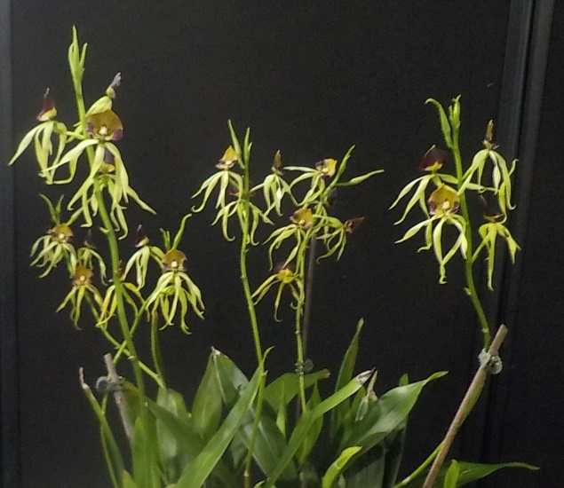
Encyclia Cochleata Margaret Turner
Novice Section
Species:
Cymbidium > 90mm:
Cymbidium 60 – 90mm:
Cymbidium < 60mm:
Aust. Native Orchid:
Laeliinae > 70cm:
Laeliinae < 70cm:
Paphiopedilum:
Vandaceous:
Pleurothallidinae:
Oncidiinae Alliance:
Seedling:
Miscellaneous:
Fern:
Foliage: Ken Covington
Plant of the Night
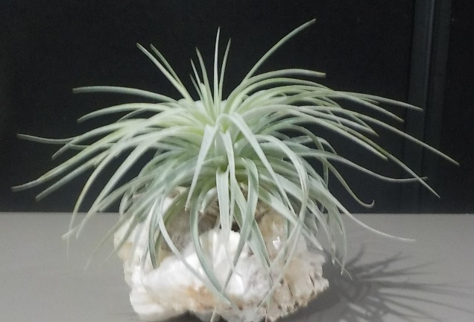
Tillandsias Ken Covington
BATEMANS BAY ORCHID AND FOLIAGE SOCIETY INC. DRAFT MINUTES OF THE GENERAL MEETING HELD SOLDIERS CLUB; BEACH ROAD BATEMANS BAY
Monday 1st February 2021
PRESENT: Members: 15 Apologies: 2 Visitors: 0
President Anne-Marie opened the meeting at 7.30pm thanking all for coming
MINUTES: accept the Minutes of the last General Meeting held on Monday 7th December at the Steam Packet Hotel Nelligen having been circulated as a true copy.
Moved: Margaret Turner Seconded: Tony Groube Carried
BUSINESS ARISING: included in the General Business.
CORRESPONDENCE:
- Magazines: Orchids Australia,
- Newsletters from Wagga Wagga, Sapphire Coast, Milton/Ulladulla, Canberra, N.S.W, Shoalhaven; EOC; Blue Mountains & Penrith Districts OS
- Bank statement
- Reminder that IBD is due to mature;
- Email from Jane Wright regarding March Workshop; (see later in minutes)
- card from Robert & Sue Fish;
- email from Dennis Lee
- request for judges for shows
- Public liability accident insurance from OSNSW (don’t use)
Out
- BBOFS Newsletters
- BBOFS newsletters to other orchid clubs
- Membership form to new member
Moved: Margaret Turner Seconded: Una Roberts Carried
2. TREASURER’S REPORT:
Treasurer Leanda presented: - Opening balance $9166.72; income $88.00; expenditure $248.95. There are no unpresented cheques. Floats remain the same, and IBD due to mature tomorrow. To be re-invested with interest to be put into working account.
Moved: Leanda O’Connor Seconded: Robert Fish Carried
December report not available, so will be presented in March.
Leanda requested permission to pay outstanding accounts.
Moved: Leanda O’Connor Seconded: Una Roberts Carried
3. GENERAL BUSINESS:
- Next General Meeting: Speaker Jane Wright from Canberra. Not sure of topic just yet, however she will bring down plants for sale.
- 16th Anniversary Luncheon: at the committee it was discussed that as this function is a bit special, we would request members to wear semi-formal type clothing. All agreed.
- Bunnings BBQ: Saturday 13th February. Margaret has 4 members for each shift. She thanked those who had volunteered to assist.
- Change to Native Show weekend dates: At the committee it was discussed that the Native Show needs to be a week later. Margaret & Anne-Marie discussed this with Ashley (Functions Manager) and moved to dates to a week later, so it is now 23rd & 24th October.
- Floral Art exhibits tonight: 2 items on display, however only one for judging as the other one has artificial flowers in it. Well done to both members who made the displays.
- Donated Bush Fire plants: Barritta and Tinone Orchids have donated plants to the members of Sapphire, MUOS, BBOFS & EOC who lost plants in the Black Summer Fires. Anne-Marie is in the process of giving these out to the members of BBOFS who have been affected. Anne-Marie has written to both orchid growers and thanked them for their kind donation.
- Show schedules: As we are hoping to have shows this year, the question as to whether or not the show schedules need to be reviewed was raised. There was a very definite NO from the members present. However, the question was asked about the Phalaenopsis section and did that need to be reviewed. Robert Fish pointed out that they were now in sizes. See below.
  - Phalaenopsis
  - Class 44A Phalaenopsis over 75mm
  - Class 44B Phalaenopsis 50 – 75mm
  - Class 45A Phalaenopsis up to 50mm
  - Class 45B Species Phalaenopsis
  - Class 46 Seedling from Class 44A to Class 45B
This is from the Winter/Spring schedule.
- Calendar of events: Anne-Marie stated that the calendar for the year was pretty full. She has asked members form BBOFS, EOC & Canberra to be speakers, which will provide a range of genre and interest for members. We will also have our usual two auctions and several field trips.
- Club printer: Margaret explained the issue with the printer and the cost associated with repairs and why she decided to have the Ink Absorbers replaced and not purchase a new printer.
- Printer Ink for Ken: Margaret suggested that we reimburse Ken for his printer ink as he has on a number of occasions printed the newsletter for us. All agreed.
- Tony: he explained that he was unhappy with Jane’s decision to defer the March Workshop until March 2022, which was originally for the clubs on the south coast. Canberra had been included as a number of their members would attend the workshops run by the south coast group of clubs. Tony is going to contact Jane and offer for EOC to run the workshop down here, possibly in May. Further information to follow.
- South and West Regional Show and Conference is due to be held in Wagga this year. The Wagga Orchid club is planning for this activity to go ahead on the October long weekend as usual.
Supper break 8.20pm
Return 8.40pm
4.Guest Speaker: Una Roberts: a member of our club since 2016. When she joined, she had an interest in orchids, but only a few in her collection and was very keen to learn more about them. Una was promoted to the Open Section at the end of 2019, following a very successful period of time as a Novice grower. She currently grows some lovely orchids and has a range of genre. Tonight she spoke about her growing areas and how she looks after her plants.
She has three separate areas in her home where she grows her orchids – one inside – the spa room and two outside – the side of the house and the back deck as well as having some orchids in pots in various parts of her garden.
The spa room has plenty of natural light with big windows on two sides of the room. As it is warmed by the sunlight, she uses a fan to help move the air around and since spacing the plants better, she has found that this has improved her number of spikes and the growths on the Cattleya and Phalaenopsis which grow in here. Una did say that she still uses the spa intermittently but regularly.
On the side of the house, she has lots of mounted Dockrillias and her cymbids. These get morning sun and afternoon shade.
The back deck is her work area and where she has 200+ sarcs, dendrobiums and oncidiini. These are on shelves facing west, so has protected them from the direct
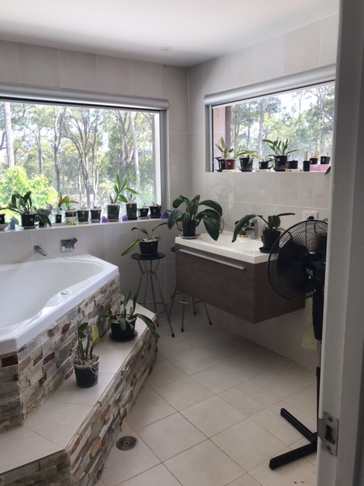
Spa Area
afternoon sun by using shade cloth and other forms of protection around the area. The deck has laser light covering it. The shade cloth allows good air flow around the shelves and Una has ensured the pots are not dislodged by placing a layer of bricks at the back of the shelves. Once again she has the pots well-spaced which also allows good air flow.
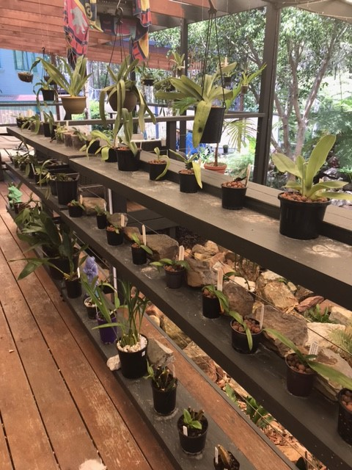
Back deck
We were shown a slide of her work area which is set up in the corner of the back deck. She now makes her own mix of hypoponic beads, small bark and small pebbles. She uses slow release fertilizer and dolomite regularly and occasionally uses liquid fertilizer.
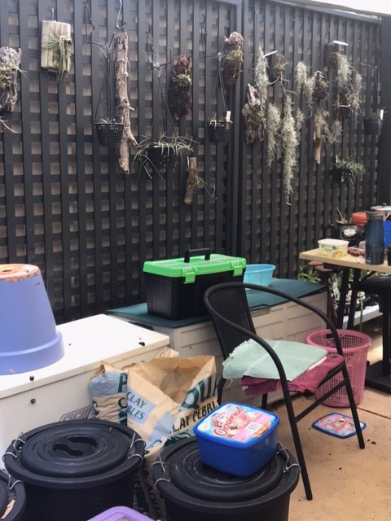
Work area
5. RAFFLES: Liz, Ken, Ron x 2, Una x 2, Jan, Leo, Margaret & Anne-Marie
LUCKY DOOR PRIZE: Margaret Turner
Plant of the Night winners were announced. Results in the Newsletter.
Meeting closed 9.18pm
The next meeting will be on Monday 1st March 2021
At Soldiers Club; Batemans Bay
Secretary Margaret Turner

Soldiers Club Beach Road
Major sponsor of our club.
Bunnings of Bateman’s Bay
Sponsoring our Club through its BBQ’s and other activities.

Apia Insurance
Specialising in Insurance for the over 50s

Supporting your community
Contact is: Peter Cordina
Mobile 0419 248 047
Email peter.cordina2@bigpond.com
Supporting our club by sponsoring our shows.

The cultural information offered in this newsletter is intended as a guide only. Bateman’s Bay Orchid & Foliage Soc. Inc. cannot be held responsible for any loss or damage that may occur to plants as a result of using this information.

